**Smart Cars & Special**

**Processors/Hardware**

**CS 6070**

**Project Documentation**

**Students Name:**

**Aakanksha Mahajan,**

**Anusha Allu, Sampath Yelchuri**

**Academic Supervisor:**

**Dr. Hassan Rajaei**

**Spring 2019**

**Department of Computer Science**

**Bowling Green State University, Ohio**

**Smart Cars & Special Processors/Hardware**

**Students:**

**Aakanksha Mahajan,**

**Sampath Yelchuri, Anusha Allu**

Supervisor: Dr. Rajaei

Dept. of Computer Science

Bowling Green State University, Ohio

Reporting date: 05/13/2019

### Abstract

Smart cars act like mobile devices themselves which communicate with the outside world i.e. other vehicles and the infrastructure without the help of any other device. The automotive industry now provides a new level of experience in terms of driving if compared to two decades before. Connectivity is what is driving the future of the Smart Cars. With connectivity and good communication, it has become possible to make vital decisions. This paper will focus on how the communication, the hardware and the parallelism can lead to in smart cars help provide an efficient and accurate behavior while driving.

In this paper, we present an architecture by integrating the Next Generation 5G network with Mobile Edge Computing (MEC) using the concept of Software Defined Networking (SDN). MEC uses the approach of forming small nodes or clusters of smart vehicles based upon their location over the edge of the network. As a result, the communication overheads using VANETs can be resolved by increasing the throughput. We also provide examples providing proof how reliable V2V communications are even how to measure the reliability of the communication of messages especially with the decentralized platoon of vehicles communicating and even predict the crashes before the collision. This paper also provides solution on parallel and distributed processing in Smart Vehicles.

### Table of Contents

*Abstract* ii

Table of Contents iii

1. Introductions 1

Purpose 1

Goals and Objectives 1

Backgrounds 2

Research Questions 2

2. Related work 2

2.1. Summary of Reviewed Work 3

2.2. Analysis and Discussions 6

3. Smart Vehicle Communication 7

3.1. Overview of Communication 7

3.2. Details of Existing Systems and Architecture 8

3.3. V2V and V2I Communication 10

3.4. In-Vehicle Communication 13

3.5. Reliability and Fault Tolerance 19

4. 5G and Mobile Edge Computing 23

4.1. Overview of 5G 23

4.2. Overview of Edge Computing 25

4.3. Details of Existing Systems 26

4.4. Strength and Limitation of existing Solution 30

4.5. MEC and Data-Warehouse 32

4.6. Evaluation and Analysis 34

5. Case Studies, Examples, Discussions, and Analysis 34

5.1. Case Studies 34

5.2. Examples 38

5.3. Discussions and Analysis 40

6. Project Steps 41

6.1. Phases and Efforts 41

6.2. Research Methods used by the Project 42

6.3. Project Strengths and Limitation 43

7. Proposal for Future Work 43

8. Conclusions 44

9. References 44

[ This page is left intentionally blank for printing purpose ]

### Introductions

Smart Vehicles being is one of the primary applications of Internet of Things with high importance. CASE – short for Connected, Autonomous, Shared and Electric vehicles will transform the Transportation in multiple ways. It is predicted that by the end of 2020, there will be 10 million self-driving cars and by 2030, there will be 1 in 4 cars which will be self-driven. Smart cars are connected to each other in the IoT system. Urbanization in rapidly increasing and so is the pollution in the environment and congestion on roads. Smart Vehicles aim on having an energy efficient, environment friendly and low accident transportation in the city.

With development in Internet of Things and 5G networks, the vehicular network communication is advancing. In addition to that, there are advancements in automotive industry and Information and Communication technologies as well. It is very important to have improved communication between the Smart objects to ensure very high performance in real-time. With improvement in communication, we can ensure safety and comfort of the passengers in the smart vehicles and road safety. Not only this, but communication can prevent accidents, provide real-time updates and real time failure identification and response.

Nowadays, there is huge focus towards standardization and interoperability involved in vehicular communication. It is important to have a check on interoperability of information which is being passed between the different infrastructures involved in vehicular communication. [1], [2] discuss about the various challenges involved in V2I communication and how important it is to not just rely on V2I communication but also on vehicle to vehicle and the best technologies to use for faster processing and less latency. It discusses how important communication is does the performance analysis of various components involved in Smart Vehicle communication.

## Purpose

This paper will discuss about the various communications involved with Smart Vehicles like Vehicle-to-Vehicle, Vehicle-to-Infrastructure and Vehicle-to-Person. Without communication the Smart Vehicles will never be able to become autonomous or driver less. To get real time updates, to avoid accidents, to provide safer and comfort to the passengers and not worry about their drive on the road, Communication is the most important element to make the Smart Vehicles robust and safe. The ubiquitous connectivity of in-vehicle computing systems and improvements in vehicle-to-vehicle and vehicle-to-infrastructure architectures enhances the contextual awareness in autonomous vehicles and furthermore guarantee safety and comfort. It is important to identify the objects correctly and the distance and the motion of the objects and that is why communication is the most important part of this project.

## Goals and Objectives

The main goal for this project will be to identify a system or architecture for a fast, robust, safe and reliable communication. The concentration will be put on communication technologies like DSRC and others, how parallel processing and distributed systems work with Smart Vehicles and most importantly focus on Mobile Edge computing because edge computing will enable faster communication and response with lowest levels of latency, delays and jitters. We will also focus on reliable communication is in enhancing the efficiency and accuracy of information in Smart Vehicles. We need to check the reliability because that is what can help us identify the failures and help avoid those failures not only internal failures of the components in the cars but also the external failure involving accidents.

*Main objectives of the paper:*

1. Provide relative latest technologies being used in Vehicular Communication.
2. We will discuss about various V2X communications and talk of the new framework of Internet of Vehicles.
3. Do research on how parallel and distributed processing can help in faster and accurate results. This part of the discussion will include Mobile Edge Computing infrastructure.
4. Smart Vehicle Communication is not possible without 5G, we surely plan to include the latest advancement on 5G in Smart Vehicles.
5. Discussions on the reliability factor of the communication and efficient and accurate results and information can be exchanged during the vehicular communication in the networks.
6. We will try to add new case studies related to the communication and discuss the possible scenarios to be achieved by Communication in vehicular network.

## Backgrounds

Interest and studies in 5G and Mobile Edge Technologies have increased. 5GPPP is the European commission and 5GAA is a global cross-industry consortium which are actively pushing the development and deployment of cellular-based V2X communications. They are building end-to-end solutions for transport and mobility services and trying to standardize the smart vehicle concepts and technologies. Vehicle to everything communication is what these groups are focusing on. All smart objects to be able to communicate with each other. With implementation of 5G and edge computing, the Smart vehicles will become distributed nodes themselves. With speedup 5G communication, there will not be any latency. Most of the issues being investigated in cloud computing will be solved with 5G and MEC. The real-time communication with high performance computing at edge is what the answer is for a Smart world.

## Research Questions

RQ1: How does communication take place using V2V and V2I?

RQ2: How does distributed and parallel communication takes place in smart vehicles?

RQ3: How reliably can communication help enhance efficiency and accuracy in smart connected cars and avoid failure?

### Related work

In this section we are going to provide the literature of the work already done. We will take a close look in terms of performance and reliability analysis of the existing components and architecture. We will closely analyze the research work and then pick up their analysis and try to start from there to provide ideas for improved solutions and then how the related work has helped us reach our new ideas and solutions.

### Summary of Reviewed Work

Shengbin Cao and Victor C. S. Lee in the research [23], present that most of the crashes and the damage that entail in the current world represent a serious challenge and this is one of the most common reasons of causing deaths of various people while travelling in the vehicles. Some statistics have shown them that majority of the issues like road crashes, traffic congestions etc., are due to the human errors and 60% of these issues could be solved by the implementation of Smart Vehicles with help of Vehicular Ad-hoc Network (VANETs). The VANETs projects the idea of having communication between Vehicle-to-Vehicle (V2V) and Vehicle-to-Infrastructure/Road Side (V2I) communication. They even show that implementation of these VANETs would reduce the risk of all the challenges that are faced by user who is driving a vehicle and passengers as well. This can be achieved only when the vehicles tend to exchange different kinds of data/information and communication with each other. For this communication to be established between the vehicles and the infrastructure/road side entities they use a practical and adaptive approach based on Time Division Multiple Access-based Medium Access Control (TDMAC) protocol. Since a Smart Vehicle also uses various safety applications which have stringent Quality of Service (QoS) requirements and efficient Medium Access Control (MAC) protocol that can provide a broadcast service by reducing the access delays while communicating with other vehicles and infrastructure. They treat TDMAC technique is an efficient way of establishing communication as this approach enables multiple vehicles to use the same channel without interfering with the other vehicle's transmissions. Their simulation results showed that compared to other techniques the proposed TDMAC has provided better performance in terms of average end-to-end delays and number of hops as well. This paper helps to answer RQ1.

Zhigang Xu, Xiaochi Li, Xiangmo Zhao et.al in their research [24] mainly deals with the communication which can established using the Vehicular Ad-hoc Networks (VANETs). VANETs is the one of the most advanced and efficient technology which can be used for transmitting data/information using Vehicle-to-Everything (V2X) communication. Basically, V2X focuses on in-terms of brining the smart information/data from outside the vehicle into it and process it accordingly using the processors for making intelligent decisions. This help the smart vehicle to make decisions based on the context and situation which is known as context aware computing. The V2X is furthermore classified into two categories. They are Vehicle-to-Vehicle (V2V) communication and Vehicle-to-Infrastructure (V2I) communication. The V2V and V2I communication works on the principle of Dedicated Short-Range Communication (DSRC) technique. According to a survey made by the United States Department of Transportation the DSRC technique helps in preventing 80% of the accidents. But this technique has not been implemented yet due to the reason that it has not been widely deployed yet. The DRSC technique not only plays a key role in providing the safety of the vehicle and users but also enhances the mobility where the user can reach their destinations in shortest time possible. The below figure represents a high-level architecture of DSRC. Generally, the DSRC architecture consists several components like the DSRC Radio, a Processor (Intel Xeon or Intel Xeon Phi), Internal Sensors of the smart vehicle and the GPS. The DSCR Radio is responsible for gathering the smart data/information from other smart vehicles and infrastructure using the GPS and the DSRC antennas. Further, this smart data is transmitted to the processor which is the heart of the smart vehicle for processing the data. Now the Driver Interface captures all the real time data during the travel with the help of Internal Sensors. Now the all the data/information gathered is now analyzed to make decisions for the smart vehicle. The support and integration of this DSRC technique with the Next Generation 5G network makes it possible to implement and deploy the smart vehicles on the roads. This paper helps to answer RQ1.

According to Kashif Naseer Qureshi, Faisal Bashir and Saleem Iqbal in their research [25] discuss about the integration of cloud computing services in various vehicular applications like enhanced communication, reliable communication with less delay, distributed communication etc. The integration of Vehicular Cloud Computing (VCC) with Information Centric Networking (ICN) is collectively known as Vehicular Cloud Networking. This is considered as one of the most emerging technologies over the last three to four years since the cloud has been fully deployed into the market. The Vehicular Cloud Computing helps the vehicular network nodes to enhance their processing and transmitting power and moreover it reduces the communication barrier in VANETs. So, in Vehicular Cloud Computing (VCC), all the smart vehicles collectively form a cloud within the services that are produced, maintained and consumed. They construct a cloud by using a collection of vehicular computing resources as shown in the below figure.

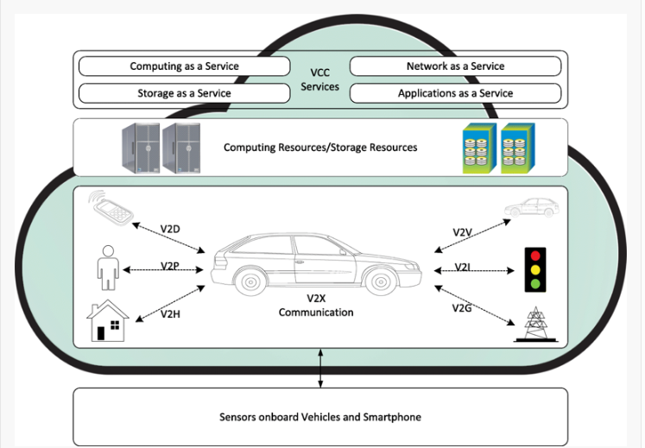

**Figure 1: Vehicular Cloud Computing for V2V, V2I and V2X communication [26].**

Information Centric Networking (ICN) basically focuses on what are the context of the data/information rather than where are the origins of the data. This technology uses the concept of Content Based Routing (CBR) approach for establishing fast and reliable communication in VANETs. This paper helps to answer RQ1.

Ahmed Soua et.al in their paper [7], proposed an architecture which includes multi-level SDN approach and an edge computing architecture for the upcoming 5G-VANET systems. They have used vehicles as the infrastructure (VISAGE) and with the help of SDN controllers, they assume that the functioning of the vehicular communication improves. When the computing services form cloud to the edge of the networks, vehicles could use the resources locally and network control decisions are made locally. By using distributed fog architecture and adopting multi-level Software Defined Network scheme, they designed in such a way that the design can respond easily for the dynamic network changes. Also, there were three use cases discussed in the paper which illustrates the way their proposed architecture improves communication and computation capabilities. This paper helps to answer RQ2.

To obtain a low-cost approach for the real-time vehicle to vehicle communication, the authors of the paper [9] propose a V2V communication system for collision avoidance. Using parallel CPU and Graphic Processing Unit (GPU), they would like to gain parallel V2V communication and parallel bandwidth optimization. As the data streaming is done in high rate, they confirm that with parallel CPU and GPU improves processing speed and therefore increases communication in between the vehicles. Their main objective is to obtain low cost V2V collision avoidance system and low power, high speed parallel bandwidth to process the data. They say that with the latest hardware that is with better CPU and CPU configurations, we can attain better parallel communication in between the vehicles. This paper helps to answer RQ2.

Yassine Maalej et.al., in their paper [10] uses a CUDA-based Graphic Processing Units (GPUs) as a model for high performance parallel computing in the Vehicular Cloud Computing (VCC) systems. They have used Vehicle to Infrastructure communication in DSRC (Dedicated Short-Range Communication) in Vehicular ad hoc networks. The authors developed an algorithm which is a fast one which helps to schedule tasks in vehicular cloud computing systems. The workload modeling of the vehicular tasks is shown in detail and architecture of the VCC is given in the paper. Greedy and MDP schemes are proposed as a result of their study for the decision making of scheduling policies. The authors also suggest that the CUDA-enabled GPUs would help to improve the performance of the vehicle. This paper helps to answer RQ2.

Le Liang et. al. in paper [3], talk about the physical characteristics of the vehicular communication. They say that physical infrastructure is the basis of providing a wireless communication and that the underlying physical infrastructure is the going to ensure interoperability and the reliability of the complete communication system. They present new channel and modulation schemes which try to solve the problem of communication in high mobility. They propose a hybrid mmWave hardware system to achieve high mobility communication. In the end they also come to the fact how 5G is going to be the key element for helping in providing a reliable communication. They also explore more challenges regarding reliability in mobile vehicular network. They say that efficient and reliable systems are the way to go but they have a lot of challenges. This paper helps to answer RQ3.

Rafael Molina-Masegosa and Javier Gozalvez in their paper [4], present how to improve reliability in the vehicular systems. They make a clear point that without radio resources, the cellular based infrastructure alone cannot provide a Smart vehicle with the features of being autonomous. The performance of the LTE based V2V is discussed and how distributed scheduling is highly important for this. They present their simulation results for their implemented protocol trying to identify the percentage ratio of the sensing, transmission and the error data. They also find issues and challenges with respect to the packet collision while sensing and transmission. Their result shows that the transmission error decreases when transmitter and receiver distances are small during vehicle interference. Further this paper we believe is helpful in answering RQ3.

The paper [5] by A. Dabboussi et. al. provides a hybrid approach of quantitative and qualitative approach to measure the reliability of the connected vehicles. This hybrid approach is basically towards exponential model of reliability giving good results of measurement. A critical statement that they make is that a very complex system and be created where the autonomous vehicle does not need to connect to external infrastructure or other vehicles and can operate by itself with the help of its own internal sensors. Therefore, they suggest it is important to have reliability measure for various components in the connected vehicle. Further this paper we believe is helpful in answering RQ3.

In the paper [6], Abdelmuttlib Ibrahim Abdalla Ahmed et. al discuss about the Intersection-based Distance and Traffic-Aware Routing (IDTAR) protocol and how it is a very good technology which aims to provide a reliable and high performance in transport in smart cities. The protocol that they propose is provides very low delay while end-to-end communication. It also provides very high packet delivery ratio if considered smart cities with smart communication and smart traffic system as well. The protocol is position based routing protocol which considers both distance and real time density information to be transmitted and processed. The authors also show the performance analysis of this protocol with other existing protocols and how this protocol will be more beneficial in communication. This paper will help in answering RQ3.

### Analysis and Discussions

Travelling from one location to another location either it might be long or short have never been easier or more enjoyable till last 5 years than in today’s connected car and yet this is just the beginning. Our cars are on a rapid evolutionary path to become more autonomous always connected increasingly efficient and a lot more intelligent which means safer roads, faster travel and cleaner air for everyone. To realize this vision, a huge research is being done on Vehicle-to-Everything (V2X) technologies like connecting vehicles through Vehicle-to-Vehicle (V2V), Vehicle-to-Network (V2N), Vehicle-to-Pedestrian (V2P), Vehicle-to-Infrastructure (V2I) basically everything. V2X lets the smart car to share the data/information in real time to avoid accidents, coordinate traffic and become more aware [25]. V2X augments various hardware, sensors, processors and computer vision with non-line sight of awareness effectively allowing the smart cars to see around the intersections and well beyond the driver vision. WIFI based 802.11p/DSRC established the foundation for latency critical V2X communication. Later a new standard of Cellular V2X communication was introduced which not only improves the safety but also enhances the situational awareness and more autonomous driving. The Cellular V2X communication defined two modes for communication of smart vehicles that work together. They are Direct Communications and Network Communications. The Network Communication leverages the existing LTE networks with ubiquitous coverage which is helpful in alerting the smart vehicles if there is any traffic congestion or an accident took place in about 1-2 miles ahead. The Direct Communication is built on the LTE direct with innovations to exchange the real time information directly between the vehicles (V2V) travelling at high speeds, high density traffic and even if out of coverage as well [24]. The transmission rate of the data is increased twice in the Cellular V2X communication when compared with the traditional DSRC approach. Building upon Cellular V2X, the newly emerging 5G will bring even more potential for the smart car with the rich road map technologies ahead for further enhancing the driving experience. Talking about reliability of communication between the vehicles and the external infrastructure, without strong communication, we cannot rely on communication. Communication can be reliable if the underlying communication infrastructure of wired and wireless technologies is fast, durable and reliable. The LTE V2V technology will prove to be the growing communication protocol and with the concept of platoon of vehicles [19] can prove to be one of the solutions for information communication.

### Smart Vehicle Communication

Smart Vehicle communication is successful only if the vehicular network supports the high network mobility required for the communication. There are high heterogenous integrations to allow communications amongst all the smart devices. Without the high network mobility, the smart transportation network and then further smart cities fail. There are multiple technologies and multiple frameworks and designs available to create a standard vehicle communication system. The below sections provide the details of components in the architecture and design of smart Vehicle Communication.

### Overview of Communication

In the VANETs, the vehicles communicate with each other and everything else by-passing messages, requests and responses. Every vehicle is identified by a unique identification or certificate. Messages transferred include the breaks, lane changes, accidents on the way to the passenger’s destination etc. VANETs make this communication happen real time using dedicated short-range network of networks which manages information shared by vehicles in the same topology. This means that vehicles in a range of distance of the vehicle can only communicate. This communication also takes place between the vehicles and the road-side units or base stations as well. Communication is highly important between the vehicle and the infrastructure as well.

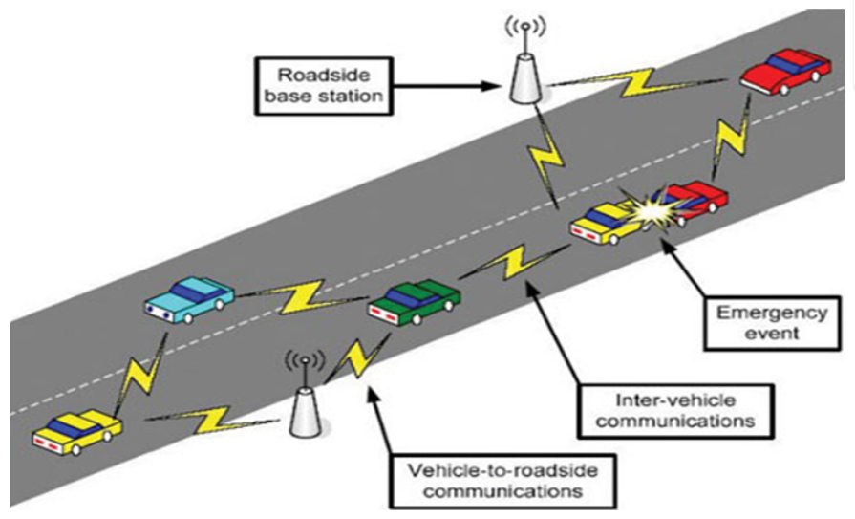

**Figure 2: A high level model of V2V and V2I Communication using VANETS [20].**

From inside a vehicle, the components and sensors also communicate with each other in the vehicle. There are hundreds of sensors inside the car which fetch the real time feed and sense the environment of all the possible scenarios like climate, failures, services, accidents, lane changes, rear views, etc. trying to make the drive safe and comfortable for all the passengers.

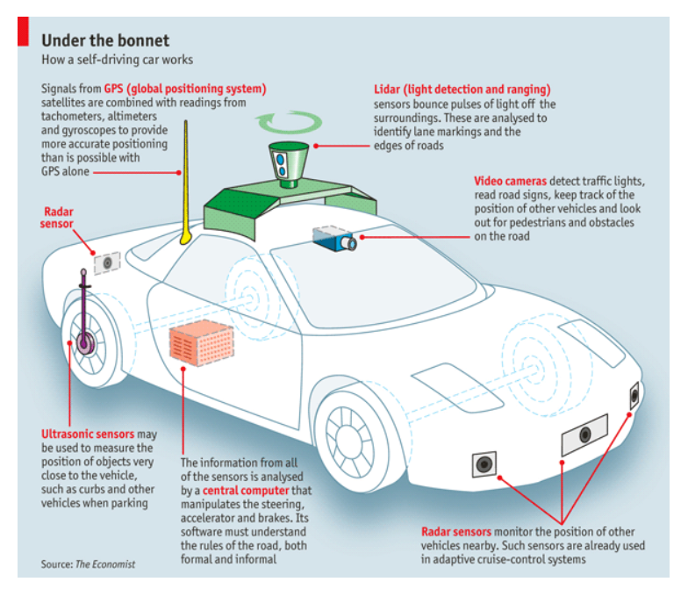

**Figure 3: Different kinds of sensors in the vehicles [20]**

The above diagram shows the vehicle having a central controlling unit receiving the sensed information from all the sensors. GPS signals provide the correct positioning of the vehicles and identifying the vehicles locations. LIDAR senses the identify the edges, lanes and the lights off the roads. Ultrasonic sensors help sense the proximity of the other vehicles or any object near the vehicle. Radar sensors are also used to monitor the position of the other vehicles. As per today on an average there are 60-100 sensors in a car. It is estimated that a car will have 200 sensors on an average because with smart vehicles on road, there can be accidents and therefore the communication and sensing and then further processing of the data at real time is the most important and hence targeting high number of sensors which in turn means better processing and handling of big data is required [20].

### Details of Existing Systems and Architecture

VANETs have been studied for a long time now. Internet of Vehicles is a new concept. Below provides the overall system of internet of vehicles. The system which is being described here is an integration of the distributed system and heterogenous data communicating with multiple systems to store and process traffic information, environmental information, failure recovery options. The data is received in streams and this is real time data processing of the streams. This helps in reducing the load on the database.

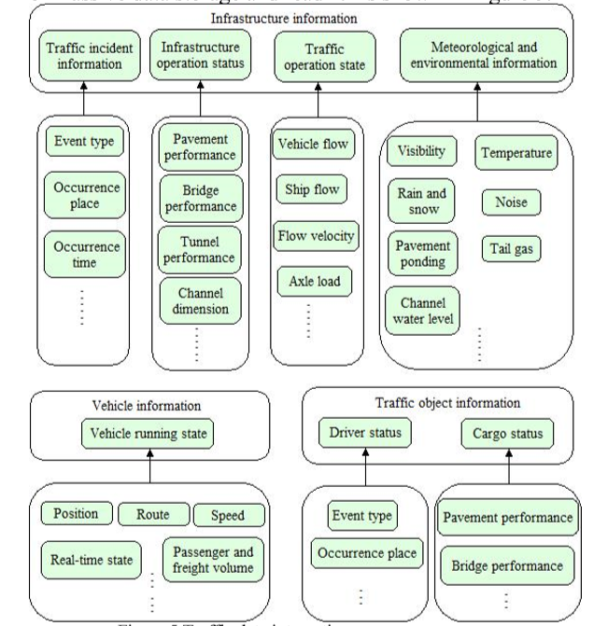

**Figure 4: Integrated Heterogenous system for sensing data and getting information out of it [21]**

Spark has proven to be on the biggest and fastest stream processing framework in big data technologies where it performs parallel and distributed processing of data real time on the streams. The below diagram shows how big the infrastructure and how the data keeps on flowing the data is continuously processed to provide traffic information, alerts on failure and recovery and response. All of this requires low latency not only in network communication, but it needs infrastructure for low latency processing of the data as well.

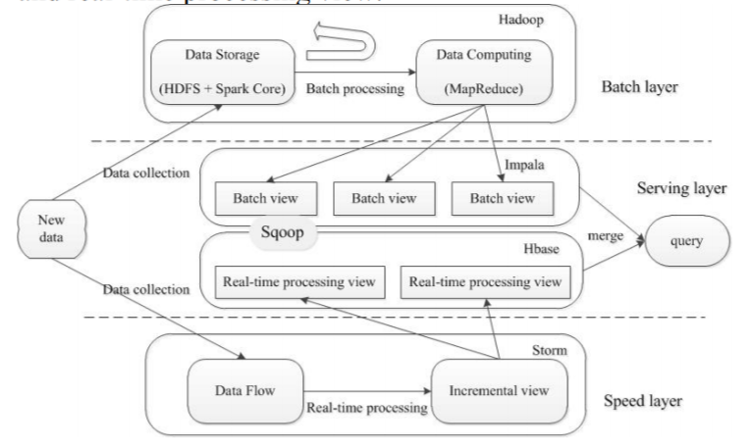

**Figure 5: Processing Layer for streams of sensed data from the sensors [21]**

Spark on top of lambda architecture will provide the real time processing of the stream data with low latency and help solve the problem of massive data access timelines. Spark provides faster data processing and analysis with the underlying parallel and distributed system. The Batch layer provides the full view of the data with the real time incoming data as well. Speed layer is where the real time data processing is happening. The Service layer is where the batch and stream views are joined together to give the while information view. With this architecture for processing, the data processing capability will improve the analysis ability as well with faster and good decisions. This platform will help provide the platform for accuracy of information, reliability and compatibility of heterogenous systems in the framework [21].

### V2V and V2I Communication

The research for various techniques used for the Vehicle-to-Anything (V2X) communication which can be implemented using two technologies. One such technology which enables V2X communication is Dedicated Short Range Communication (DSRC). They assume that when DSRC is combined with Global Positioning System (GPS) technology, the result is a low-cost Vehicle-to-Vehicle (V2V) communication system that provides a 360-degree view of similarly equipped vehicles within communication range [27]. Transmitted messages common to all the smart vehicles include current GPS position, vehicle speed, acceleration and heading vehicle control information such as the transmission state, break status, steering wheel angle as well as the vehicle’s path history and path prediction. They also discuss about the approach of V2X communications using a hybrid DSRC-Cellular communication technique with the help of already existing cellular network base stations as shown in the below figure.

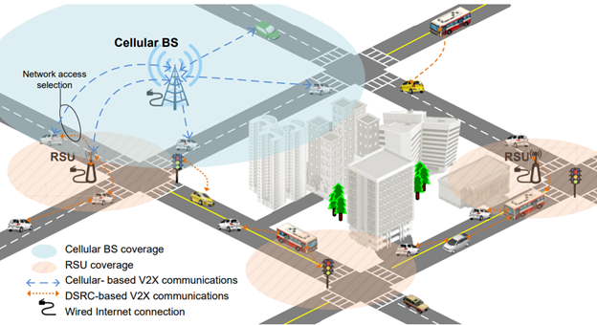

**Figure 6: Implementation of DSRC with the existing Cellular Network for V2X Communication [27].**

And they even say that it is very important that the information transmitted by every smart vehicle is anonymous and it does not include any personally identifying information such as name, license plate number etc. And it is also important that it includes a sophisticated security system to make sure that the information exchanged among various vehicles and entities is authentic and can be trusted. By employing common data, security and communication standards, V2V interoperability can be achieved. Using a common approach of communications standards, it would be easy for various automotive industries to develop their own applications for their smart vehicles that will increase the coordination among different smart vehicles manufacture by different companies [27]. They also compare to the Vehicular network architectures proposed by IEEE 1609.0 standards of North America, ETSI EN 302 665 proposed by Europe, ARIB STD-T109 proposed by Japan with the traditional Open System Interconnection (OSI) Model as shown in the below figure.

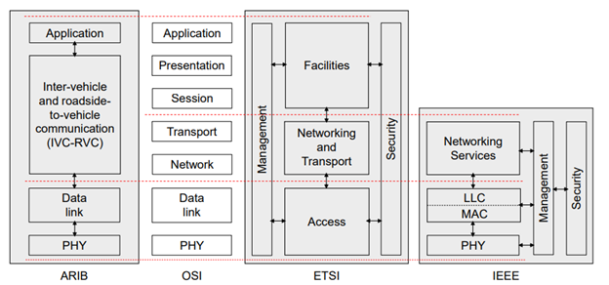

**Figure 7: Comparison of various Vehicular Network Architectures by various countries in reference with the OSI model [27].**

A special hardware design is required for the implementation of the DSRC technique for exchange of data/information between the smart vehicles using the Vehicular Ad-hoc Network (VANETs). A wireless transmitter is required to be designed in such a way that it is responsible for outsourcing the data/information sensed by various sensors of the smart vehicle. This proposed wireless transmitter is designed based on the standards of IEEE 802.11p of wireless vehicular communication. The DSRC transmitter has a high linearity of 5.9 Ghz which helps in Vehicle-to-Vehicle (V2V) and Vehicle-to-Infrastructure (V2I) communication [28]. The DRSC transmitter includes an amplifier which is programable called the PGA, an amplifier drive (DA), an adapter or frequency regulator called Up-converting mixer (UCM) and a Local Oscillator (LO) buffer. The high-level design of the hardware looks as shown in the given figure below.

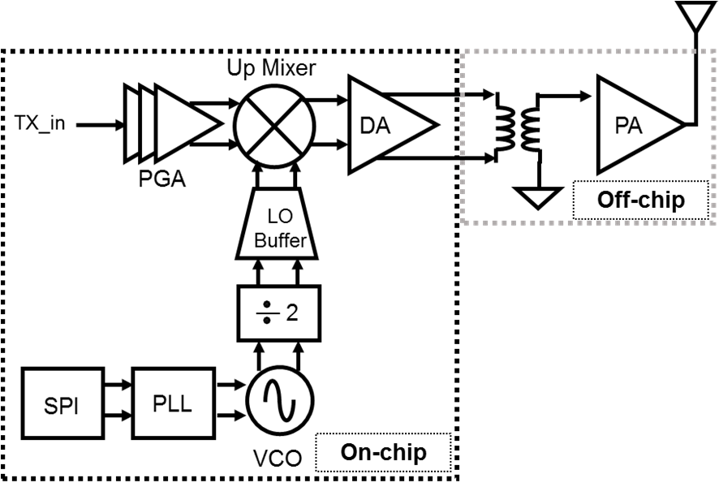

**Figure 8: Hardware Design of DSRC Transmitter [28].**

Including this hardware, we also need an architecture as shown in the below figure which can be used to implement the cellular based DSRC technique in-order to establish Vehicle-to-Vehicle (V2V) and Vehicle-to-Infrastructure (V2I) communication in smart vehicles. In this architecture, we basically form two type of network nodes. One network node is a dynamic communication cluster known as the Mobile Network Node (MNN) which is handles the continuous communication between smart vehicles or Road Side Units (RSU) with respect to their mobility [29]. And the other network node is the static communication cluster known as the Stand-Alone Network Node (SNN) which includes handles the communication between the stand-alone vehicles or the road side entities.

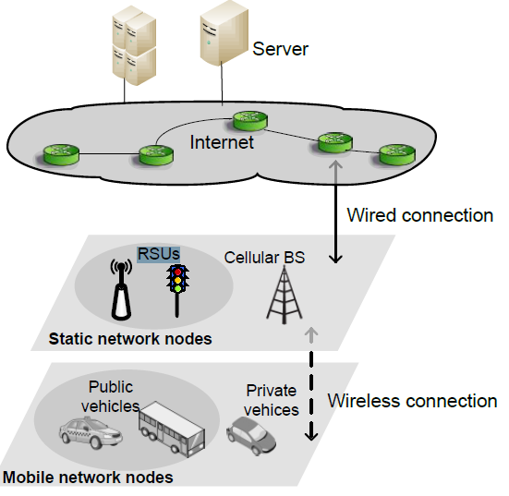

**Figure 9: A Two-Tier Architecture for the implementation of DSRC technique [29].**

### In-Vehicle Communication

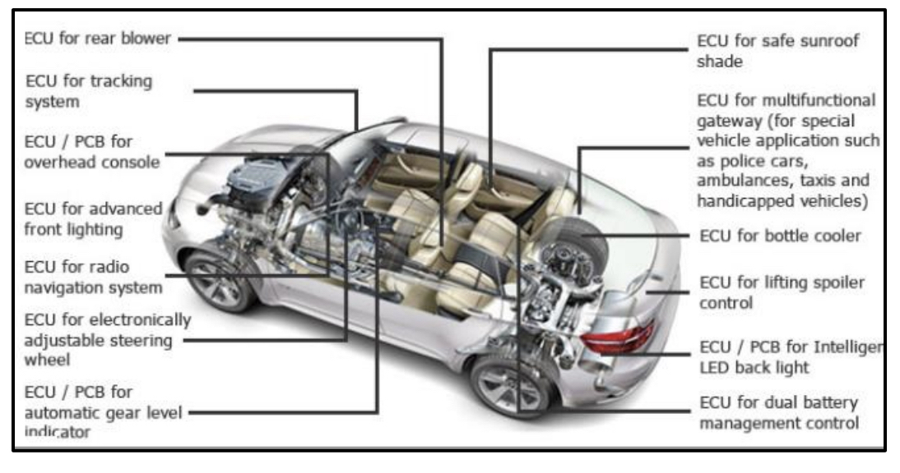

**Figure 10: Different ECUs to control vehicular functions [11]**

In-Vehicle communications will have various ECUs, sensors, and actuators. The count of ECUs can range from 30(simple car) to 100 in luxury car. The number of sensor nodes inside a vehicle is tremendously increasing. The reason behind this is to achieve safety, security, and convenience within a vehicle. The communication within the sensor nodes of a vehicle can best happen using Controller Area Network which is a wired architecture. These wired architectures will not be useful when there are many sensor nodes and the design of this type of architecture is very complex. This brings in wireless architectures for communication purpose in the vehicles. This type of wireless communication within the vehicles is classified into three different classes by SAE (The Society of Automotive Engineers). They are classes A, B, C and D.

**Classification of Different automobile applications [11]:**

1. **Class A**: This type of class demands the lowest data rate. This type of communication help to give a data rate of less than 10kbps. It can be used for transmission of sensors and actuators which are used for body and comfort event-driven transmissions. Door locking sensors, seat position sensors, wiper comes under this class.
2. **Class B**: The second class helps to support the data transmission rate of 10kbps to 125kbps. This class supports non-critical communications. That means any delay in the communication will not render failure in any system within the vehicle.
3. **Class C**: This type of class helps to give a high data rate transmission compared to class A and B. Braking systems, control of engine and suspension, etc., where action must occur within milliseconds of time, this type of class is used.
4. **Class D**: Class D supports to attain high data rate communication that is over 1Mb/s. It is expected to give high bandwidth especially for media-oriented transmissions like GPS and Advanced Driving Assistance system (ADAS).

**Communication Bus Protocols in In-Vehicles**:

There are few protocols used for communication inside vehicles to meet the needs of Electronic Control Unit (ECU) multiplexing. They are as follows [12]:

* Local Interconnect Network (LIN)
* Controller Area Network (CAN)
* FlexRay
* Media Oriented System Transport (MOST)
* Ethernet
* Power Line Communication (PLC)

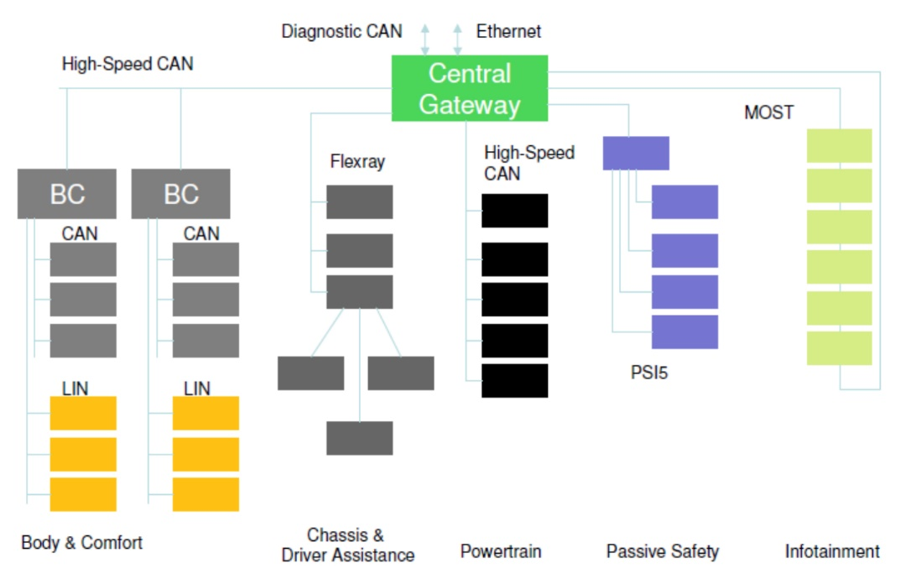

**Figure 11: In-Vehicle Communication Architecture [11]**

In the above figure, we can see how three different classes of ECUs communicating with each other. Powertrain and chassis, infotainment, passive safety, and body electronics are some of them. Two CAN buses connect all these ECUs. One bus is for powertrain, the other CAN bus connects body electronics such as door and climate control. The FlexRay network protocol is for driver assistance, the MOST network is dedicated for infotainment, LIN network supports to provide body and comfort. There will be a Central Electronic Module ECU which will act as the main gateway among these buses. It is very common that nowadays, cars have more than 80 sensors with all these networks exchanging about 2500 signals.

**IoT in Intra-Vehicular Communication:**

Among all the protocols, Controller Area Network (CAN) is mostly used protocol for wireless intra-vehicular communication. It is secure and realistic as it is serial communication. Low speed CAN will help in Class B applications and High-Speed CAN allows real-time functionalities. MAC protocol of CAN uses carrier sense which can carry up to 8 bytes of data in one CAN frame. However, when there is increase in the number of sensors, CAN protocol is not flexible and then, wireless architectures help in such scenarios. Also, CAN is not suitable for safety-critical applications. To meet the high demand of deploying various sensors to bring more sophisticated electronic systems into use, it is good to have IoT in intra-vehicular communication, which can be referred to as Intra-Vehicular Wireless Sensors Networks (IVWSN) [13]. In this IoT enabled network, various sensors are connecting to each other to share the data sensors generate and to develop a smart car. For this type of wireless sensors networks, different networks like ZigBee, RFID, Wi-Fi, and Bluetooth can be used to make use of IoT. These sensor nodes communicate with each other to share car sensor data.

Among all protocols, the ZigBee communication protocol is a dominant technology for intra-vehicular communication. This design provides a real-time monitoring system with low cost, high data rate, and energy efficient wireless communication system. ZigBee can be used in vehicular positional coordinates using VANETs [13]. For driver assistance, road safety, fatigue detection, and comfort, IoT needs to be included within the intra-vehicle communication. With Intra-Vehicular Wireless Sensor Networks placed on top of the vehicular devices, we can collect important information like speed, data, acceleration, temperature and so on.

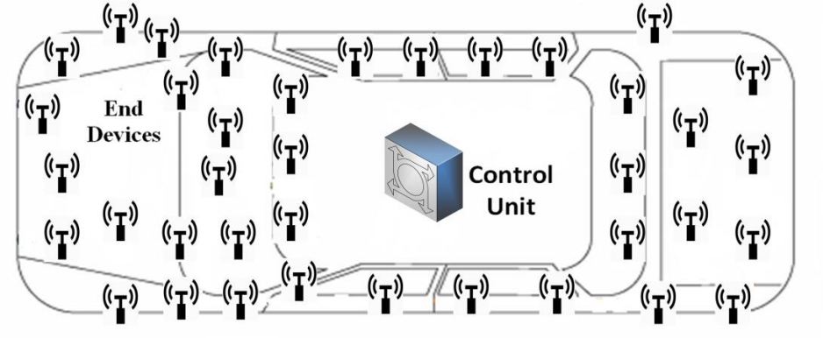

**Figure 12: IoT enabled In-Vehicle Wireless Sensor Networks (IVWSN) [13]**

With the help of IVWSN, we could achieve better performance as the cost, weight and fuel consumption of the vehicles can be reduced. In the above figure, we can see how different sensors retrieve the data from the main components of the vehicle and this data is sent to the central Control Unit which helps to monitor the functionality of the system.

Rahman et.al., in their paper [13] discusses a network architecture of this IVWSN, in which there are three components namely end-device, control unit (CU) and display. Figure shows the network architecture and Data Flow of the network components. Every end device has a transmitter and a specific sensor. The sensors will sense information from this transmitter and the component and send the data to the control unit. Control Unit will have the Transceiver and the Processing Unit (PU). The Transceiver sends and receives the data to the CU and Processing Unit decides whether to send the information to the display or not. The display shows the current information.

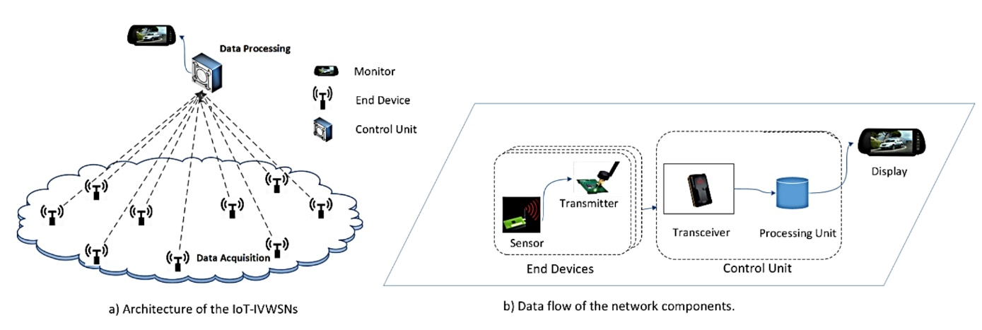

**Figure 13: Network Architecture and Data Flow [13]**

The performance of the system depends upon the design of the network architecture. In the above figure, the authors mention that they have considered a two-tier architecture in which one is Information acquisition layer and the other is the information processing layer. In information acquisition, data is gathered from various components in the vehicle. The data collected is given to CU and PU will process the data. Single hop star topology of the network is considered in their paper where every end device gets the same signal strength. In this topology, it is easy to reconfigure the network. The data flow of the network components is also shown in the above diagram.

Wi-Fi, UWB, ZigBee, and RFID are few wireless technologies that can be used in these wireless inter-vehicular networks. Bluetooth is a short range and not suitable for battery-enabled sensors. Ultra-Wide Band is a radio technology which can get a data rate of 480Mb/sec. RFID couldn’t meet the latency issue and reliability requirements. ZigBee is best among all those wireless technologies which can support star, mesh and hybrid topologies and its MAC protocol is a useful one as it has CSMA/CA features which allows data transmission robustly [13]. This protocol allows many sensor nodes within the same network, this makes this network protocol to be preferred than others.

**Parallel Communication in Smart Vehicles:**

This section answers RQ2, which is about how to achieve parallel communication in In-Vehicles.

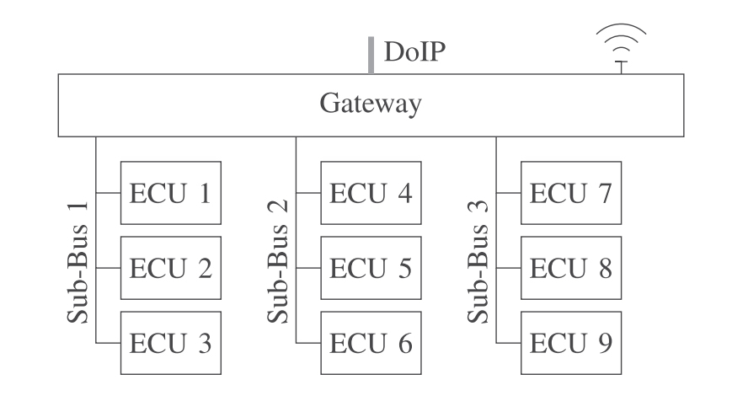

**Figure 14: Current Intra Vehicular Network (IVN) Architecture using a Central Gateway [14]**

Nowadays, the architecture of Intra Vehicular Network (IVN) is based upon a centralized Gateway system. Here in Fig x, we see that there are multiple ECUs connected with different buses. The Gateway's main functionality is for physical connection for all the ECUs using the bus. The bus systems used for different levels of operation are CAN, FlexRay and LIN. Authors say that the diagnostic tester would be communicated with the diagnostic interface. The interface in the future systems would be the Ethernet with Diagnostic Communication over Internet Protocol as in the Fig x. The reason behind this for moving to Ethernet protocol in future is due to the requirements of digitization [14]. To achieve parallelism and to gain more efficiency, DCU (Domain Control Units) are needed. As the Ethernet protocol offers high data rate, high bandwidth is offered with less cost. That might be the reason for preferring Ethernet protocol in the coming Inter Vehicular communication. For parallel processing of any updates or for data processing, the IVN architectures must be suitable for them. The gateway or DCU must transfer various packets for the communication bus. While achieving parallelism, few factors must be considered like:

* The bus shouldn't be overloaded with parallel data transfers, this can form data packet losses
* Must maintain certain number of parallel processes. The data packets reaching gateway need to be sent to different data frames. Many requests sent as parallel will lead to overload of the bus.

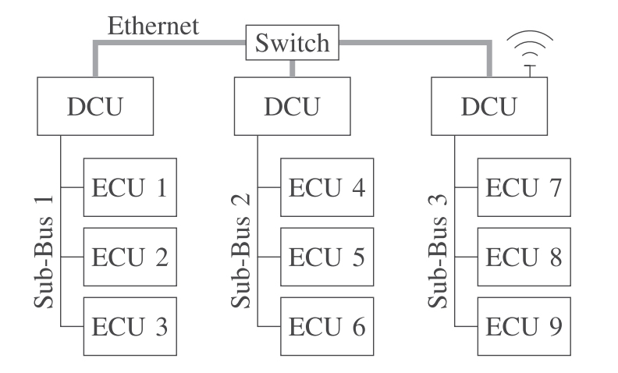

**Figure 15: Future Intra Vehicular Network Architecture using Ethernet as the backbone and via DCUs [14]**

In the below figure, the gateway of the DCU will collect data of many ECUs. Each DCU will decentralize and send the data to the network in parallel way. To meet the demands of parallel programming, high data rate protocol which is Ethernet is used. When the number of these ECUs increase, parallel processing will help to reduce the programming time for various ECUs on multiple networks. the above figure can also be represented in more details like in the following figure which is the simplified network configuration using Ethernet. The data transfer can be parallelized by transmitting re-programming data for multiple ECUs in the same time that the data is sent to single ECU. In this way, data parallelism can be achieved.

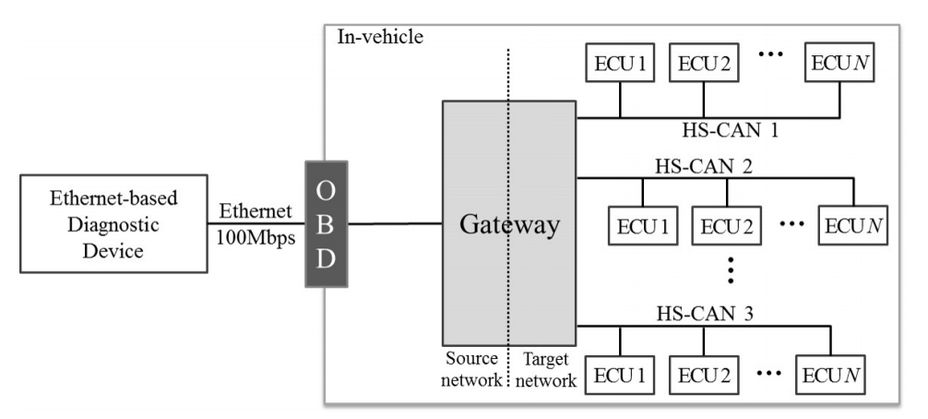

**Fig 16: Simplified Network Configuration [15]**

We will have **multicore** systems for automobiles which lets to handle huge amount of data coming into the system and going out of the vehicular system. Software components must be integrated with less ECUs. Large Scale Software Integration techniques need be applied for the coming software architectures which will enable smart cars to run smoothly with high performance. Software Components must be loosely coupled to integrate on a single ECU. To handle multi-core system, the software of the vehicle should be redesigned and restructured to enable parallel processing. The below figure describes the possible way of partitioning the ECUs and allocating to different cores which helps for parallel processing.

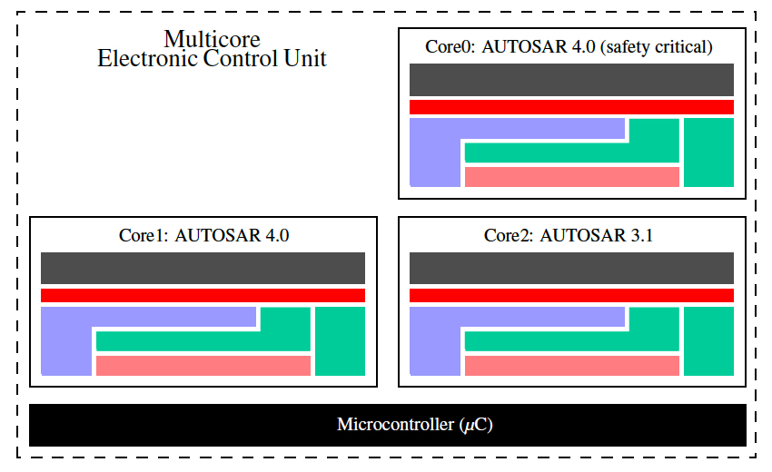

**Fig 17: Possible partitioning adapted for multiple ECU projects in Multicore components [16]**

**Intel Atom Automotive Processors** will help to give better performance to in-vehicle experiences. The Central Processing Unit of a vehicle which does all the computing in the vehicle can be Intel Atom and Intel Xeon processors. The computing capacity of the vehicles will be increasing with low-power package. Intel Field Programmable Gate Arrays (FPGAs) supports the smart vehicle autonomous driving features. These include in-vehicle computing by providing a high performance and they are also power efficient.

**Intel Xeon Processors CPUs** will help to deliver a high-end autonomous car especially for level-4 and level-5 cars. Level-4 is the semi-autonomous types of vehicles and Level 5 driving automation includes complete autonomous vehicles. The processors like FPGAs, GPUs, Intel Xeon Processors inside the vehicle can help to support driver assistance, entertainment, safety precautions and so on. In-Vehicle entertainment includes software and hardware which will have navigation systems, audio-video players and so on. **Arm** multi core CPUs is in market, using this process we can achieve multithreading in the vehicles, which results in parallel communication and thus, result in more performance.

### Reliability and Fault Tolerance

The performance and reliability of the Smart Vehicle communication is worked upon these days and there are companies like Google with their autonomous driving projects have successfully achieved a good percentage of reliability. American Automobile Association in 2016 confirmed that the idea of self-driven vehicles is not accepted by at least half of the U.S drivers [22].

According to NHTSA, in 2016, there were 10 million motor-vehicle crashes occurring resulting in 37,000 fatalities [22]. Research into DSRC for vehicular communication has been going on since 2002. In 2011, different global automobile companies started using DSRC in their vehicles and irrespective of the vehicle make they could communicate with each other. The US Government officials are also making efforts to work with European officials to create global standards. Most of the vehicles now have alerts that V2X technology gives, like blind-spot, lane-change, and forward-collision warnings. But these are provided through radar- and camera-based sensors and cover a limited area around the vehicle.

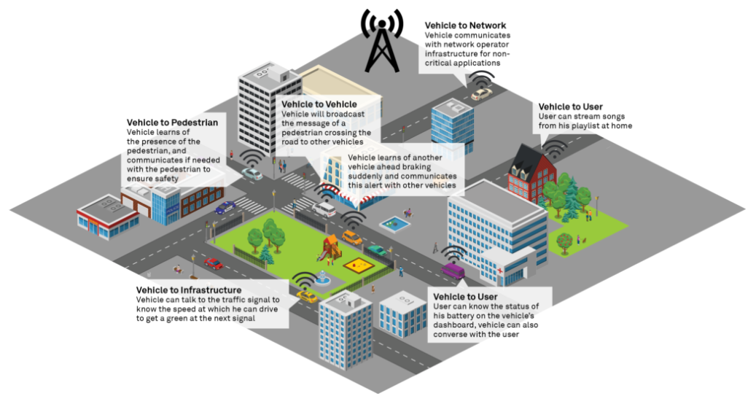

**Figure 18: Different Communications possible between vehicles and outside world [22]**

For the propagation of such messages, the following communication protocols are used:

**DSRC/ IEEE802.11p**: It can communicate for relative vehicle speeds of 250km/h. With DSRC network, it is unable to ensure high reliability and safety of communication of messages and information. There is a little latency involved and if three are messages being transmitted at the same time overlap each other and which in turn results in message being dropped. Also, the range where is can communicate is 150-300 mts which means that to be able to communicate the objects or vehicles or the infrastructure should be in this range. To be able to come over this issue, DSRC requires to deploy extra units called Road Side Units leading to large implementation and use of DSRC networks [22].

**LTE-V2X**: This is the next well utilized network communication protocol which is likely to evolve towards 5G. It does not require any extra infrastructure and can leverage the existing cellular infrastructure. The benefit of LTE-V2X is that, in the absence of a network connection, it relies on the V2V communication frequency for communication of safety messages. It supports relative speeds of 500 km/h or more. Also, the range for LTE-V2X is greater than 450m, which basically provides the driver with longer reaction time. LTE-V2X requires very high clock synchronization resulting in the need for better and expensive hardware. The clock synchronization guarantees that no messages are dropped. Hence, synchronization between the message and the clock is needed for messages to always be captured and processed [22].

There is a Data Age MAC scheme which ensures reliable communication between the vehicles. This scheme is like an alternate to the standard IEEE 802.11p standard. The latter communication protocol fails to provide reliability requirements of communicating messages in the vehicular networks. This scheme also provides early detection based on power control. This framework is basically proposing safety critical data exchange during driving based on the data age of the earlier received data messages exchanged by the vehicles inside and other platoons of vehicles. With retransmission, the reliability of the communication has proved to improve [19].

The below diagram shows the intra-platoon communication with one vehicle as the leader along with one or more following vehicles.

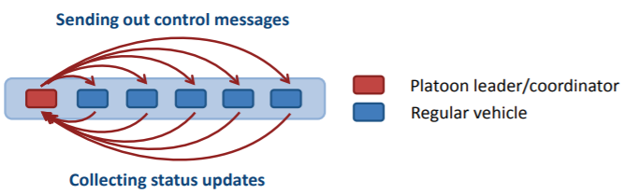

**Figure 19: Platoon of vehicles communicating with each other [19]**

The leader is the coordinator which is responsible for getting all the updates from all the vehicles. There is a super frame structure used for communicating and coordination internally in the platoon of vehicles. The beacons are sent out by the coordinator. Any vehicle which has an event to report can access the channel. There are 2 phases: Collection and Control phase. Each vehicle in platoon can send out messages and then retry the unsuccessful messages as well. The coordinator sends the individual platoon members status updates during Control Phase and this process is also open for retransmission [19].

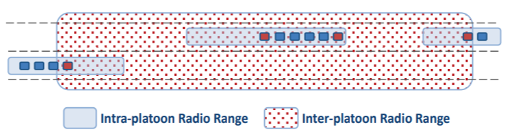

**Figure 20: Inter and Intra platoon communication of vehicles [19]**

The above figure shows the arrangement of inter and intra platoon radio range for communication.

Coming to inter platoon communication, it is also very important and good way for communication as well for safer operation of the vehicles. Every platoon has a service channel in which the communication takes place. A platoon can meet another platoon. They identify the platoon through the platoon announcements and every platoon has its own Super frame for communication in that channel.

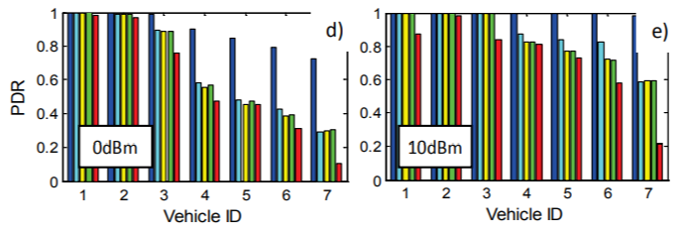

**Figure 21: Packet Delivery ratio vs time graph suggesting reliability [19]**

Simulations have been performed on this framework. The above graph provides simulations on 7 vehicles in a platoon communicating with each other and the data rate is 6Mbit/sec. In the above graph the Packet Delivery ratio sent by the individual vehicles in the platoon to the coordinator. The lower the output power of communication between the vehicles, higher is the probability of early platoon detection without interference. A scheme without retransmission achieves on 50% of the last platoon vehicle. For 7 vehicles platoon it requires a little higher Power but better PDR results of 97% [19].

The below graph shows the CDR results which compares the Data age of the Status Updates. Looking at 5 vehicles at 0 dBm, a Data age of around 20 ms was recorded for 97% of the Super frames. A DA of 60 ms, with two unsuccessful packets in a row resulted in less than 0.1% of the SF. The corresponding DA for CSMA packets showed a worst case of 380 ms, with a loss of 18 packets. Next comparing performance at 10 dBm: DA-RE shows a rate of 99.99% for a 5 vehicles platoon, whereas only 60-80% of the SF reported a successful SU reception for CSMA [19].

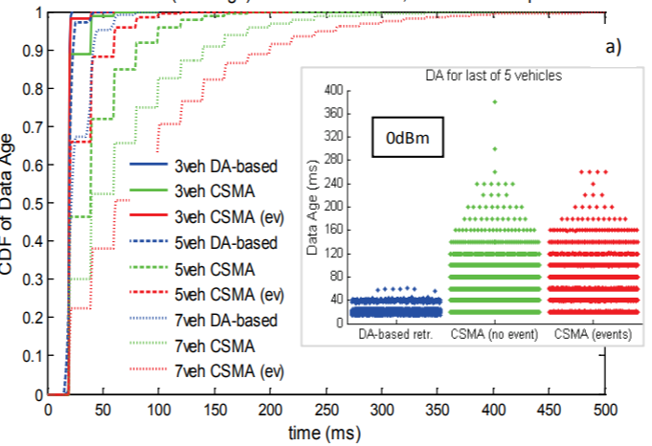

**Figure 22 a: Cumulative Distribution frequency of status updates based on data age vs time with 0dBm [19]**

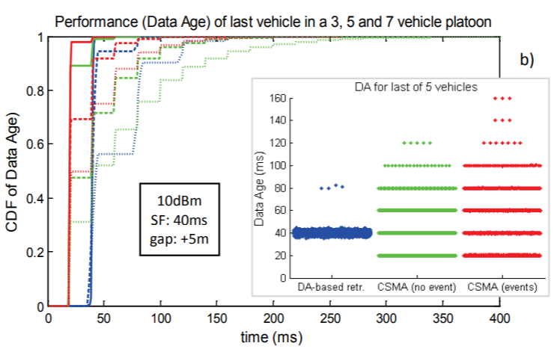

**Figure 22 b: Cumulative Distribution frequency of status updates based on data age vs time with 10dBm [19]**

Now this system is centralized to have a central vehicle acting as the control system or the coordinator of all the vehicles in the super frame. If we tend to have a decentralized system of platoon where the vehicles communicate data to one another and pass it along the other vehicles, then that could be considered as a good recovery and re transmission of packets, and faster failure detection and better power consumption.

There are still concerns on the how the autonomous vehicles react and respond in rad hazards and different weather situations like heavy rains and snowfall especially. Basically, the whole Smart Vehicle communication works on the array of sensors which sense environment data, the sensors not only the vehicle but also the infrastructure sensors. The sensors could get dirty, or they could get damaged or obscured by snow, so without the sensors sensing properly, how can the communication be reliable, and this kind of blur communication might lead to a new hazard instead of preventing it. The biggest challenge is to equip maximum infrastructure and the vehicles with the smart sensing processing environment to be able to communicate with each other. If they do not communicate then we will never be able to achieve high reliability in the smart vehicle communication system.

### 5G and Mobile Edge Computing

### Overview of 5G

The below figure gives the multitier network architecture for 5G. The 5G next generation includes the following features [33]:

1. Macrocells
2. Small cells
3. Femto cells and WiFi
4. Massive Multiple Input Multiple Output with beamforming
5. Device to Device Communication
6. Machine to Machine Communication

This architecture deals with high traffic volume, massive connectivity, improved energy consumption, improved network capacity and data speed and latency reduction.

5G expects to have small cells be deployed densely to offload the power from the macro cells. Small cells can be deployed indoors and outdoors with very low costs. With low radius of the small cells the spectral efficiency of the spectrum increases. With a macro base station in the middle to receive the radio requests and provide a signaling service while the small cells still be responsible for high data transmission.

5G utilizes higher band spectrum which is the millimeter wave band providing around 6GHz bandwidth. It is further being predicted that future 5G systems might use 20-30Ghz band. But Millimeter waves are restricted and constrained with signal getting atmospherically absorbed, constraints on hardware, etc. [33].

1. One challenge is high path loss with mm wave. To avoid this mm-wave can be used with high antennas in line of sight which will help in reducing the path loss.
2. Another challenge is that mm-waves can be easily absorbed atmospherically by oxygen and vapors.
3. Another challenge is that the mm-waves can easily penetrate through solid materials and therefore get lost. This issue can be reduced by performing high attenuation.

Beamforming and Massive MIMO are the key technologies for 5G [33]. Beamforming helps to provide powerful signal strength by focusing on the signal from the device. Massive MIMO as well helps to strengthen the signal and provide higher throughput and quality. Massive MIMO basically groups together antennas at transmission and receiver thereby increasing the spectral efficiency.

Therefore mm-wave deployment with beamforming and M-MIMO provides the highest advantages.

Latency reduction is another key feature of 5G. It is said to have less than 1 ms latency. Reduction in latency is achieved via D2D communication and mm-wave cells.

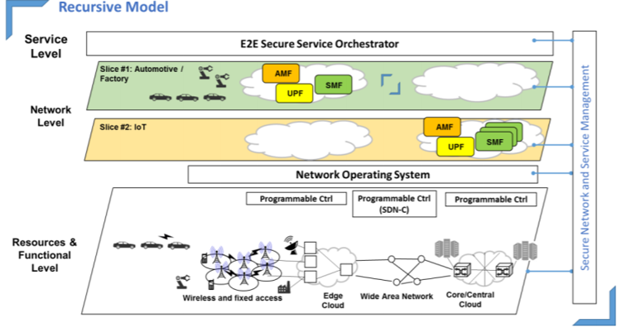

**Figure 23: Latency Reduction Model in network communication [33]**

The overall architecture is shown in the above diagram provided in the whitepaper [33] presented by the team of 5GPPP. The 5G network includes cross-domain functioning involving Software Defined networks, virtualized network functions, end-to-end network slicing. 5G abstracts the underlying resources from the SDN layer. NFV and SDN allow the usage of the same resources by different tenants.

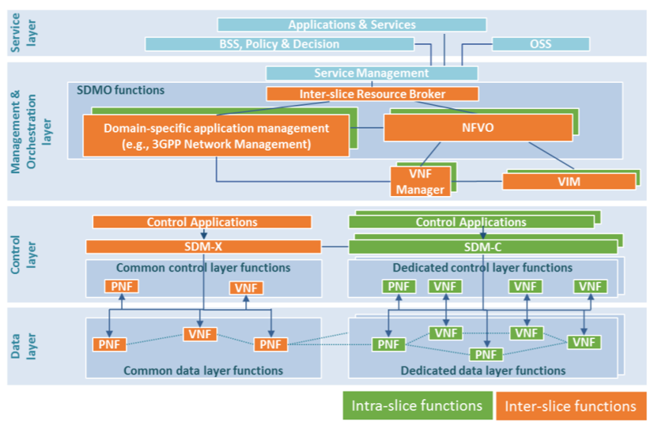

**Figure 24: Different functional layers in 5G network communication [33]**

There are 5 functional layers in the architecture of 5G shown in the above diagram [33]:

1. Service Layer: which consists of the Applications and services, different policies and decisions followed by tenants.
2. Management and Orchestration Layer: includes the Network Function Virtualization and network slicing like it includes ETSI NFV MANO functions basically for all network handling.
3. Control Layer: This layer helps in translation of decisions into commands using Software Defined Functions and principles consisting of SDM-X and SDM-C controls.
4. Multi-domain Networking Operating system facilities: This layer includes the provisioning of resources related to the networks and tries to maintain reliability in the multi-domain areas.
5. Data Layer: consists of the VNFs and PNFs to process the user data.

### Overview of Edge Computing

Edge Computing terminology has been around for a long time now. There are still researches going in this domain.

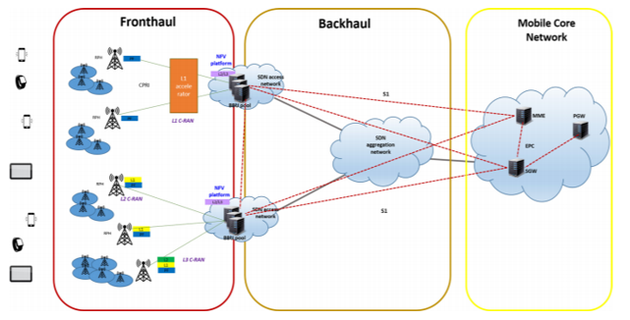 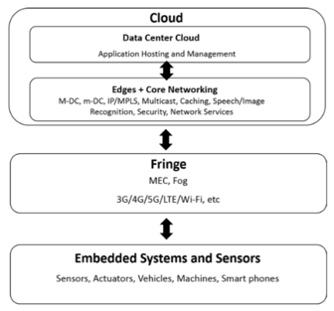

**Figure 25 a and b: Latency Reduction Model in network communication [33]**

The above diagrams provide the architecture involved in Hierarchical Edge Computing

The fact is that all applications are distributed, and more and more real-time applications are being created and they require guaranteed quality of service in the networking system. Mobile Edge Computing came into investigation in ETSI 5G mobile network specification in 2014 where it could be a breakthrough as a cloud computing to provide virtualized network services. MEC enables network slicing to create service specific virtual networks. The network slicing support low latency end-to-end mobile data communication from Radio Access Area to Cloud Core Network in front haul and back haul segments as shown in figure 26 a. above. MEC cloud platform is located on base station servers where it provides a delay between the end users’ mobile device and Mobile Core Network no more than 1 ms, and it results in location awareness in the applications. European researchers are way ahead and has demonstrated that MEC plays a key role for automatic or autonomous driving. The latency of connecting car if compared to the traditional remote DC is no less than 100 ms and MEC puts down this latency down to a 20 ms.

### Details of Existing Systems

Internet of Vehicles have evolved from Intelligent systems to Cognitive Internet of Vehicles. The phases that are seen during this evolution are Intelligent Transportation System, Vehicle Ad Hoc Network, Internet of Vehicles and Cognitive Internet of Vehicles.

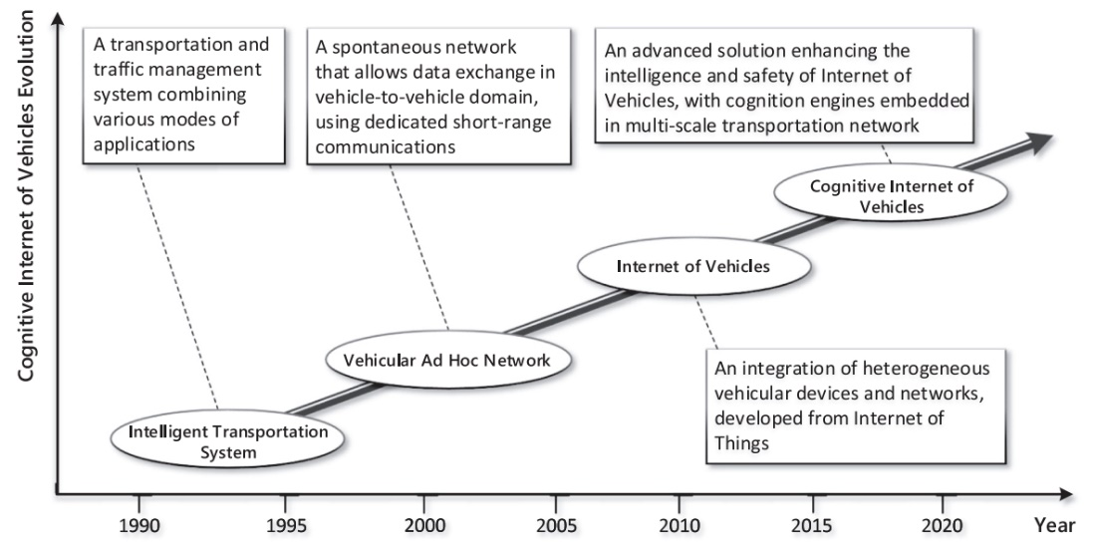

**Fig 26: Internet of Vehicles Evolution [16]**

**Intelligent Transportation System:**

ITS is the concept before the year 2000. It basically consists of traffic light signal system, automatic license plate system and vehicle recognition system [16]. For example, Using the electronic tags of the vehicles, the vehicles are recognized using a wireless RFID technology. This is an example used for paying tolls, transportation and traffic management systems combing various modes of applications.

**Vehicle Ad Hoc Network:**

To improve the safety and to improve the transportation, researchers were working in the ways to achieve communication between vehicles. This is through Ad Hoc networks. For a longer time, Vehicular Ad Hoc Networks were the main research area and under the main spotlight area. Vehicle to Vehicle communication mainly uses DSRC communication technology. Due to the high mobility of the vehicles and as the infrastructure also is not ready to accept these technologies, there are still problems with VANETs. This is the reason behind VANETs alone couldn’t support communication in between the vehicles and they can’t support autonomous driving.

**Internet of Vehicles:**

Evolution of Internet of Things and big data paved path for the emergence of Internet of Vehicles. With a compliance on the same communication protocol and data interaction standard, wireless communication can happen using the Internet of Things which applies to vehicles. A communication and the exchange of the information can take place between vehicle-to anything that is vehicle-vehicle, vehicle-infrastructure and vehicle-pedestrian.

**Cognitive Internet of Vehicles:**

The problem of bringing intelligence in performing tasks is possible by integrating artificial intelligence to the Internet of Vehicles. To combine physical data space and network data space and to mine the data and send only the required information to the users in a fast way is achieved using this CIoV. Using this, driving capabilities of the driver can be increased drastically by alerting the drivers of fatigue conditions.

**Cloud and Edge -Based Communications [17,18]:**

A part of the answer of the question RQ2 is explained here in this section. The question is to how to achieve distributed communication in smart vehicles. Cloud computing provides powerful computational and storage capacity which obviously reduces the cost of hardware and the deployment infrastructure. Edge is bringing the cloud services near to the user. There are several advantages of edge computing, this helps to reduce the latency, this leads to increase in the network performance. Cloud computing architecture gives a distributed nature of sharing resources, processing and even the storage. Edge Computing brings processing close to the data source. This doesn’t need to send to cloud or other centralized systems for processing. By eliminating the distance and time to send to centralized sources, speed and performance can be increased with this concept. This allows faster analytics and reduces network pressure. Edge computing is recently termed as fog computing. Fog computing is simply to deploy the virtualized cloud-like device closer to mobile users, and therefore the Fog is interpreted as “the cloud close to the ground”. With the concepts of 5G Network Slicing, Software Defined Networking, Network Function Virtualization, we can achieve distributed nature of communication between the vehicles and vehicle to infrastructure.

*5G Network Slicing:*

As 5G allows more computational capabilities and allows special features such as close to the users by making available resources near and improvisation of the customization capability and providing more friendly resources. For the challenges like scalability and extensibility, a focus on Network Slicing has been a need. Network Slicing would improve the efficiency and the cost also reduces using this model. The concept of network slicing came to provide better resource isolation and increased statistical multiplexing. It also can be defined as a concept for running multiple logical networks as an independent operation on a common physical infrastructure. Each network slice represents an independent virtualized end-to-end network. It can be termed as specific instance of such a logical network. This network slice has specific customized functionalities and uses network function chains to deliver services to a group of devices. Network slicing can support on-demand services for distinct application scenarios at the same time using the same physical network. Supported by network slicing, network resources can be dynamically and efficiently allocated to logical network slices according to the corresponding demands [17]. Researchers have proposed network slicing strategy based on Software Defined Networking. Some have introduced network sliced mechanisms for network edge nodes to offer low-latency services to users.

*Software-Defined Networking (SDN):*

To enable centralized and programmable network control, SDN separates network control and data forwarding functionalities. SDN separates network control and data forwarding functionalities to enable centralized and programmable network control [18]. In SDN, there will be network administrator who can shape traffic from a centralized console. SDN architecture consists of three layers: the application layer, the control layer and the infrastructure layer. Application layer has network applications like firewall, load balancing or intrusion-detection systems. Control layer manages the flow of the network and is the main part of the software defined network. The final layer infrastructure layer consists of physical switches.

*Network Function Virtualization (NFV):*

NFV uses a network architecture concept which is a new way to design, deploy and manage networking services. ETSI developed Network Function Virtualization (NFV). It uses the technologies to virtualize entire classes of [network node](https://en.wikipedia.org/wiki/Network_node) functions into building blocks that may connect, or chain together, to create communication services. NFV separates the network functions from hardware appliances so they can run in software. This helps for the service providers who want to accelerate their deployment of new network services to the existing one. NFV introduces an abstraction of the underlying infrastructure upon which virtual networks with alternative architecture may be constructed to meet diverse service requirements. NFV uses the concept of network virtualization and provides more specific mechanisms to decouple service functions from infrastructures [17].

**Cognition-Based Communications:**

Cloud/Edge framework will help to achieve Cognition-based communications. It is best useful to meet the real time requirements such as to know real-time road conditions and to know the conditions of the driver in real-time. There will be a good connection between the cloud and the edge frameworks. As the edge nodes cannot handle huge amounts of data and has limited computing capacity, the data is sent to the cloud for the storage. Architecture of Cognitive Based networks need to be more well-structured as it involves complex tasks. Intelligent decisions must be taken within no time.

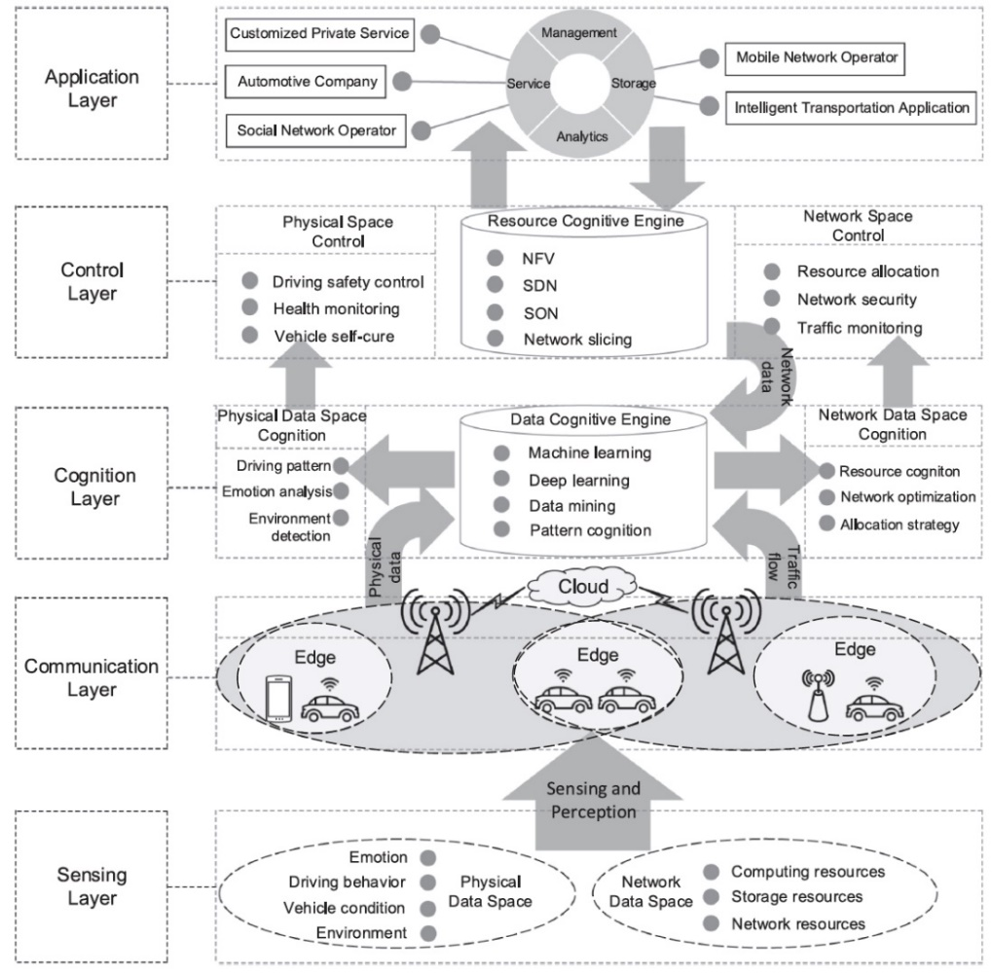

**Fig 27: Architecture of Cognition based IoV [16]**

The above figure gives the idea of how the architecture of Cognition based Internet of Vehicles would be. To fully utilize the features of the distributed communication, the data must be fetched accurately and precisely. With the information received from the edge, the consequent actions of the autonomous car will be decided. To change lanes, to know the distance between the other vehicles, to act immediately when car must stop for hazards, these all types of actions can be taken with the intelligence and data mining techniques. Network allocation to the resources using intelligence would be beneficial. Driving patterns, Emotion analysis, Environment detection can be done with ease using the Artificial intelligence algorithms and data mining techniques. This reduces the cost and improves efficiency of the vehicular communication.

### Strength and Limitation of existing Solution

**Strengths of the current IoV Solutions:**

With the 5G enabled edge computing, there are several advantages. Network resource sharing is easier, the rate of the data transfer from the vehicles to the edge and vice versa would be very faster. There will be heterogeneous data coming out of different vehicles, the management of data becomes easier with SDN, NFV and Network Slicing.

*Strengths of Software Defined Network and NFV using 5G* include simplified and enhanced network control, flexible and efficient network management, and improved network service performance.

* Troubleshooting network problems has become easier. With increasing complexity of wide area network, it’s always difficult to maintain. Software defined networks provide better visibility of the network flows. Any change in the network can trigger actions to identify where the problem is, therefore, issue can be solved easily.
* The dynamic features of SDN enforces appropriate use of the network. There’s more and more real-time and video-on-demand traffic is being a challenge on wireless networks. SDN allows to use the network correctly and limit the bandwidth to something where it is not necessary.
* Resources can be virtualized in this network and resources are allocated to the application or service which requires it.
* Multiple Internet connections combined with multi-path technology can give better performance in this Software defined networks.
* SDN also solves the problem to make the network agile. SDN brings a level of dynamism to the network. This gives the ability to implement new services.
* Integrating SDN and NFV in networking may trigger innovative network designs that fully exploit the advantages of both paradigms
* Benefits introduced by NFV include simplified service development, more flexible service delivery, and reduced network capital and operational costs [17]

The most important strength of edge computing is to use 5G technology and this leads to increase of the data rate. As data can be accessed at the edge locally, the time to access the resources is less by decreasing the latency. The **speed** of up to 10Gbps can be achieved. Using 5G, the provided bandwidth increases, and this helps to stream videos and help in 3- dimensional map viewing. As the Edge computing distributes resources, processing and storage, this will try to avoid attacks like Denial of Service and Power Outages. Also, because of this distributed feature of the edge computing architecture, the way to introduce new security protocols is easy by not making the complete network off. This way **security** can be achieved by distributed communication in between the edges. Edge computing gives a less expensive model to the **scalability** feature. Nodes are scalable and can be increased as to our wish. This will help even when the number of smart vehicles increase in the society. Without changing much of the infrastructure, the edge datacenters could handle various types of data generated from the vehicles. In this way, edge nodes could handle versatile data from various vehicles generated from the cars. With these advantages, there is a less chance of loss of data as data is distributed, this makes the vehicular network communications **reliable**.

**Challenges in 5G Vehicular Communication Networks [16]:**

**Ultra-high Rate and Ultra-low Latency Vehicular Communications:**

* Fast and real-time data exchange is important among the vehicles and between the edge and the vehicle. It can be of both small data like speed, direction of other vehicles and large data which involves continuous streaming data or 3D maps. Many of the investigations that are being done as of now are related to the low-mobility scenarios which can cover low-latency vehicular communications. Because of the high mobility in the vehicular networks, there is a chance of inter-carrier interference which may lead to degrading the performance of the vehicles. Also, because of the high mobility, heterogeneous data, different network topologies, and to meet quality of service requirements, the accessing of resources and data sharing among the vehicles is a big challenge.
* **Wireless System Architecture for Self-Driving:**

The vehicular networks have vehicular networks and there would be multiple requirements for each vehicle. To adjust to the real-time communications, and for faster information exchange, a distributed architecture must be designed. The architecture must be designed in such a way that it will feature end to end data storage, allowing transmission and control of the network which consists of highly mobile nodes. Also, scalability is also a challenge that must be handled by the autonomous cars.

* **Orchestration and Automation**:

Internet of Vehicles have multiple number of heterogeneous devices like sensors for drivers and passengers. Communication network for intra vehicles and for Vehicle to Vehicle is a complex one. Computing with a high performance is required to meet the demands of accessing different devices and heterogeneous data. Management among different varieties of networks is important.

* **System Performance**

There are several limitations of the vehicles while taking the control decisions. This might be due to the weather conditions or because of the complicated road conditions. During such critical time, the accuracy of the sensors would be decreased. When sensors with ultra-high accuracy are developed, then we might overcome this challenge. Even though there is a deep research going on in the field of convolutional neural networks, there is a chance that the images couldn’t be recognized exactly and there may be failures.

* **Privacy and Security:**

When many Internet of devices are connected to each other, there is a chance of information leakage. The location of the vehicle, personal interests of the drivers and lot many private information of the drivers and the passengers is at risk. This is because the sensors capture the information and this data can be shared to other internet platforms. So, there is a need to protect the data from the intra-vehicular networks. Vehicular devices with low intelligence can be easily attacked and whose information is not encrypted is easier for attacks.

* **Power Supply:**

Batteries would be the main energy storing device. As Internet of Vehicles is slowly evolving, there is lot of requirement in the batteries. As the vehicles have many sensors which collect real-time information all the time while vehicle is running needs high-power consumption. Researchers are working on how to improve the energy efficiency of the batteries to overcome the demands in Internet of Vehicles.

### MEC and Data-Warehouse

The Mobile Edge Computing (MEC) is basically built on the recent advancement in the Mobile Cloud Computing (MCC) [30]. The Mobile Cloud Computing (MCC) works on the principle of storing huge amount of data/information which is being produced by various IoT devices in the real world, provides the service of processing or computing the data and helps in out-sourcing the data as well. Basically, MEC provides a shared pool of resources which can be utilized either by any individuals or an organization. The given below figure shows a typical configuration of an MEC network.

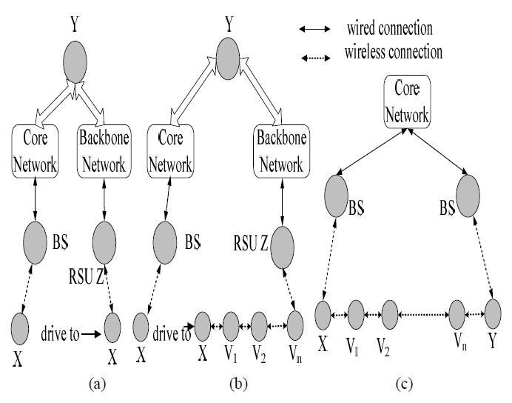

**Figure 28: A high level representation of MEC network [30]**

The approach for the data offloading is based upon the integration of Mobile Edge Computing (MEC) with the emerging 5G technology. Using the data offloading approach, we can reduce the cellular traffic in the network and cost of data transmission as well [30]. The VANETs data offloading using 5G and Mobile Edge Computing (MEC) is one of the most advanced solutions for establishing enhanced communication between the vehicles and infrastructure.

Moreover, the support of the Software Defined Networking (SDN) in the Mobile Edge Computing (SDN-MEC) increases the rate of data offloading in Vehicle-to-Vehicle (V2V) and Vehicle-to-Infrastructure (V2I) communication. Here we present a high-level architecture for data offloading the data/information using the SDN-MEC. The architecture includes SDN-MEC server, Base Station (BS) and Core Network as shown in the below figure.

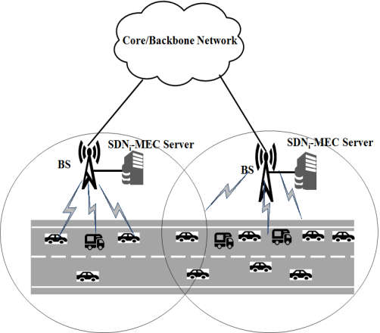

**Figure 29: High level architecture of SDN-MEC for V2V and V2I data offloading [30].**

Initially, the SDN-MEC server continuously checks for an existing communication path between the vehicle and vehicle or vehicle and infrastructure with the help of the DSRC Cellular network that we have discussed in section 3.3. Now the data/information received from various contexts are stored in the SDN-MEC server which is later processed for making decisions for smart vehicles. If there is any existing communication path between any two smart vehicles or vehicle and road side unit, then the SDN-MEC switches the communication medium from the DSRC Cellular network to the VANET network for V2V and V2I data offloading through the base stations (BS) [30]. Here the SDN-MEC server acts as the Data-Warehouse or the communication hub for the smart vehicles which helps in storing, processing and out-sourcing the data from various vehicles and infrastructure.

### Evaluation and Analysis

In 2025, future life style claims to be the days for various warble smart and mobile devices and will be an integral part of our life with augmented reality and virtual reality. Proximity based services may go beyond our dreams and expectations. However, under the limit of the current mobile communication network architecture and the specter, there are many obstacles ahead which can be summarized into three challenges.

Challenge 1: Users holds the behavior of changing his/her position from time to tome and needs more capability of higher-order of image processing so that the demand for high computation power of various smart devices connected in the smart vehicle increases.

Since the traditional Cloud network architecture does not meet the requirements of implementing the smart vehicle in terms of establishing and offloading data from one vehicle to another vehicle or a road side entity, we need a centralized mobile cloud which can also be termed as cloud-let for better and fast communications.

Challenge 2: This is one of the most important issues where the user(s) demand for a low latency, high bandwidth and ubiquitous communication to be established by deploying small cells which could expand the capacity transmitting the data.

Challenge 3: Mobile traffic bursts will cause network congestion in the future. This can be addressed by the newly emerging 5G technology by lowering the Capes and Opex.

Therefor with the help of 5G and Mobile edge computing, the data offloading mechanism for establishing Vehicle-to-Vehicle and Vehicle-to-Infrastructure communication will increase by reducing the level of network congestions.

### Case Studies, Examples, Discussions, and Analysis

### Case Studies

**Case Study 1: Vehicle-to-Vehicle Communication using Visible Light Communication.**

Communication using Vehicular Ad-hoc Networks (VANETs) was recently tested by few of the researchers at National Taiwan University. They have used Vehicle-to-Vehicle communication for establishing a connected network among all the smart vehicles using Visible Light Communication (VLC) [31]. Visible Light Communication (VLC) is a newly emerging technology which is used in the concept of visible light. In this technology, various IoT devices in the smart vehicle communicate with each other with the help of a common medium which is nothing but the visible light.

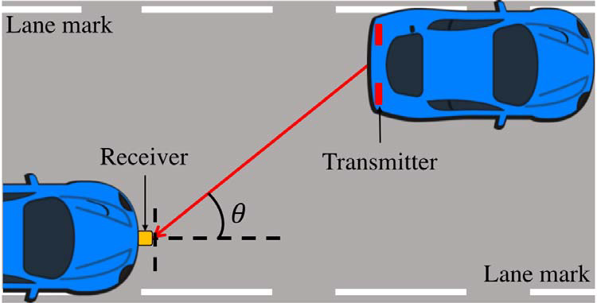

**Figure 30: V2V communication using VLC [31]**.

A visible light is a small portion of Electro Magnetic (EM) spectrum. Basically, the wave length of this visible light ranges from 380nm to 750nm. So, out of the complete Electro Magnetic (EM) spectrum, the visible light range is in between 380nm to 750nm. Now with this wave length, they use a frequency from 750THz to 428THz for transmitting and receiving data or information from other smart vehicles [31]. With the help of various software and hardware configurations, they have successfully achieved in establishing communication between two vehicles within the range of 45 meters.

They have tested this approach of establishing communication using a couple of Ford Focus 2015 vehicles. Basically, they have used a LED Taillight which is an in-built device for all the vehicles as the visible light who range of visibility was around 45 meters. They also introduced the LIDAR which is a sensor or hardware component which is used for measuring the position of the one vehicle with respect to other vehicle and they have also used Antennas for Wi-Fi V2V communication [31]. The high level of implementing the hardware components into the smart car is shown in the below figure.

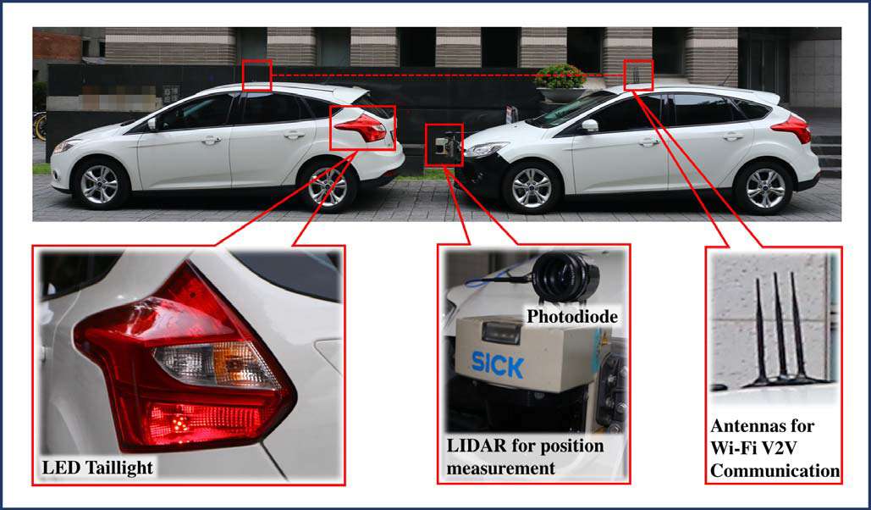

**Figure 31. Hardware Setup for V2V Communication using VLC [31].**

The proposed Visible Light Communication (VLC) setup was designed for two different purposes. One is deployed in the leading/ first moving smart car which in their case is considered as a smart vehicle which transmits the data using the four hardware components which are directly connected to the smart car. They are Laptop, Universal Software Radio Peripheral (USRP) N200, Taillight and Front-end Board. And the hardware components were deployed on the other smart car which is responsible for receiving the transmitted data. This receiver system includes a LIDAR, Laptop, PDA, USRP N200 and a GPS Tracker. The below figure represents the entire setup of both the transmitter and receiver [31].

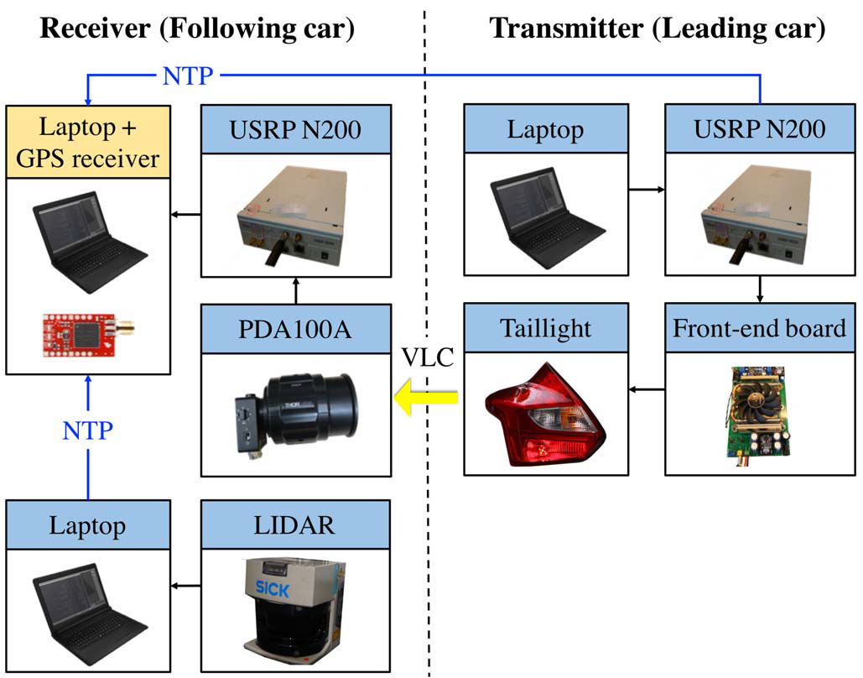

**Figure 32. Hardware support for Transmitter and Receiver [31]**

**Case Study 2:**

Communication between the vehicles needs to be highly reliable at real time because vehicles are always moving, and it means that the communication between them is always fluctuating. Here is an example and an algorithm proposed where a crash can be predicted without any contact between the vehicles by combining the various parameters like the vehicle dynamics the receptive sensors, vehicle-to-vehicle communication. This will help in minimizing the accident effect. The V2V communication used to predict the time to collision and how severe the crash can be. It is predicted using the video camera, laser range finder and ego vehicle motion sensors [34].

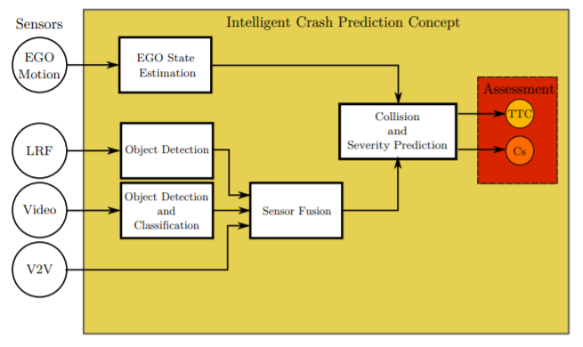

**Figure 33. Architecture for Intelligent Crash Prediction [34]**

Firstly, identify the vehicle with potential collision. With target tracking and sensor fusion, using LRF and video cameras all the detected objects are identified and checked for false positives relative to the position of the vehicle and discarded. The nearest associated vehicles are accounted for and line segments are associated to them Now with the help of the V2V data, the velocity, mass geometrical dimensions and the positions of the vehicles are noted. Once all the data is collected cartesian coordinates are selected. With changes in velocity, geospatial position and acceleration and line change, the collision can happen or not is identified.

A model is created based on motion and the measurement data available from the nearby objects or vehicles. Based on this model, it can be predicted the time to collision. As per their assumptions, the vehicles are going to collide, and the driver does not have time to react to the crash that is going to happen.

**Test Results [34]:**

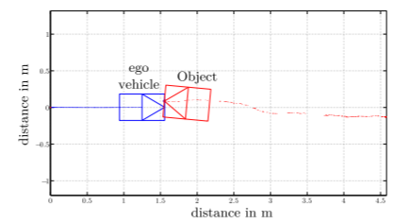

**Figure 34. An example scenario using the sensor measurements**

**Ego Vehicle:**

1. Hokuyo UTM-30LX scanning LRF is picked to measure the vehicle’s horizontal contour and determine its position in a range up to 30m of the scale model.
2. Video camera to detect objects nearby
3. WLAN access point provides wireless connections to realize a V2V communication
4. Optical rev-counters and a Xsens miniature gyro-enhanced attitude are used to measure the vehicle’s acceleration and velocity.

**Scaled Target model:**

1. Almost like the ego vehicle but additionally performs V2V communication with sensor.
2. Equipped with a sensor-architecture to determine self-movement and transmit parameters and measurement via WIFI using UDP transmission model.

**Results:**

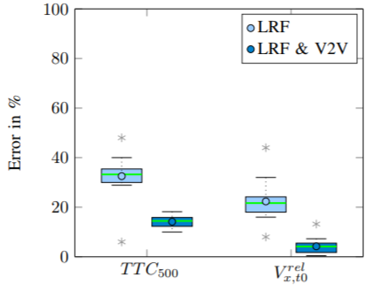

**Figure 35. Architecture for Intelligent Crash Prediction [34]**

Time to collision prediction TTC500 = 500ms before collision is evaluated.

TTC error without V2V (33.6%) is higher than using V2V data (21.66%)

Mean Vx error using V2V data is smaller (5%) when compared to the mean error (14%) using ego sensors. So, we see with V2V communication data, the prediction quality and reliability enhance [34].

### Examples

**Example 1: A vehicular cognitive application: mobile healthcare scenario [16]**

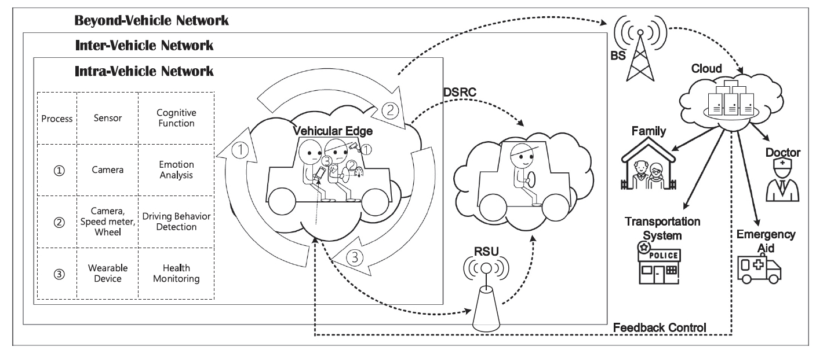

**Fig 36: A vehicular cognitive application: mobile healthcare scenario [16]**

Cognitive Internet of Vehicles improves transportation safety and network security by data mining important information. This information is gathered from both from physical and network data spaces. The above figure shows an example of mobile healthcare surveillance, which follows this Cognitive IoV architecture and this will also allow multiple smart device communications. The health of the driver is very important as that will depend the driving patterns and this will also lead to the safety of the passengers as well the people in other vehicles. When the driver will have poor health or if he is fatigue, then his driving patterns change and the attention for the driving reduces. This also increases the response time for braking, and this may lead to accidents.

Cognitive intra-vehicle communications will perform the emotion analysis, driving behavior analysis and for health monitoring. The camera inside the intra-vehicle network will check for the patterns of driver's emotion with the vehicle-mounted edge device to perform analysis. Eyelid state and the micro-nod of the driver is detected, and this will check if it is the micro-sleep behavior and do analyze with the collected data from the intra-network communications like the steering of the wheel, smart odometer. If that matches with the sleeping behavior, then a warning is given. The health and psychological data are also monitored from the smart clothing and wearable devices and this data will be continuously collected to the vehicular edge to perform real time analysis. The distributed nature of the edge network will help to give continuous real-time analysis and information is transmitted without any loss. The health status of every passenger is collected and mined by the data cognitive engine and this will lead to open a window in neighboring vehicles stating the ill condition information of the driver by sharing to all nearby vehicles. The information is also sent as a warning to nearby drivers, cloud and then the driving-mode switches to automatic mode of the vehicle. Cloud will start distributing the resources by dispatching to perform deeper analysis of the driver. In the same time, the cloud will share driver’s information to the ambulance, doctor and the driver’s home. This is first example for Research Question 2 where the related study is discussed in the previous sections.

**Example 2: First Automotive Simultaneous Multi-threaded CPU Core**

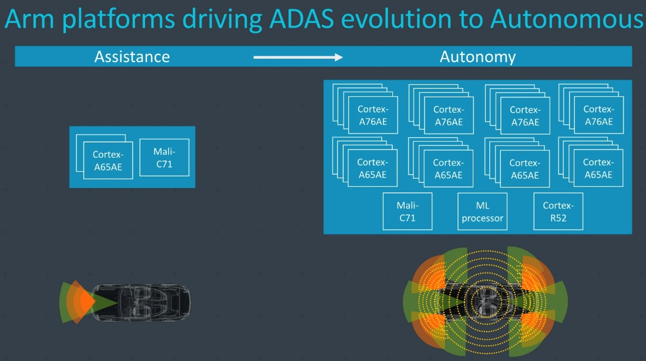

**Fig 37: Arm company introduces first multithreaded CPU for autonomous vehicles [32]**

In December 2018 [32], Arm company has introduced new next gen processor for autonomous vehicles. It is Cortex A76AE CPU. This processor provides multithreading which enables parallel communication. There are features like Dual Core Lock-Step and Split-Lock system which enhances safety and strength of the communication within vehicles. Same code is executed in parallel way and that will identify if any inconsistency among the two cores. If there is a problem with any one core, then the whole system does not shut down, instead it will rely on the other. This processor aims at high performance on heavy computational tasks. This A76AE core works in a lock-step mode. Different clusters of CPU cores are responsible for different workload tasks. In this way, parallel communication is achieved inside the vehicles. This is an example for Research Question 2 where the related study is discussed in the previous sections.

### Discussions and Analysis

The use of cellular network has increased the scope of establishing Vehicle-to-Vehicle (V2V) and Vehicle-to-Infrastructure (V2I) communication. The process of transmitting or offloading the data using the Vehicular Ad-hoc Networks (VANETs) takes place only when there is path for communication between the two vehicles or infrastructure. If the path for communication does not exists, there is a need for creation of a new connection that needs to be established between the smart devices connected within and outside the vehicle. The proposal of integrating the 5G architecture with the Mobile Edge Computing (MEC) enables faster communication using the concept of Distance Short-Range Communication (DSRC). The proposed SDN-MEC architecture also supports Lifetime based Network State Routing (LT-NSR) which enable various smart vehicles which move a high speed to communication with each other. This LI-NSR is also capable of handling path recovery in case if there is any failure in any of the smart devices of the vehicle.

Parallel communication inside the vehicles can be achieved by having Intel Xeon processors. With the different network protocols used with in the vehicles, Ethernet would be the backbone of the future intra networks. This will enable faster data rate and helps to achieve parallel communication. Having multiple DCUs will enable to have shared distributed model and this will lead to gain more parallelism, thus avoiding latency and further avoids accidents. Multicore and multithreading combines to give high throughput in smart autonomous vehicles. We see the evolution of the Internet of Vehicles that have come from Intelligent systems and that is trending towards cognitive Internet of Vehicles using Artificial Intelligence and Data Mining. With the distributed edge communications within and outside the vehicles, the security, reliability and scalability increase and there is a low chance of losing the data.

Talking about the communication between vehicles and the infrastructure and then how reliable it is, we see the decentralized platooning system for communication can prove to be very reliable. As it helps in retrying and retransmit the messages being communicated between the vehicles and everything else. Especially if tried with platooning of vehicles in 5G network. There are very high chances that we can reduce higher latency and achieve autonomous driving with this. Also, we have mentioned a case study in the paper describing how V2V communication can help predict the crashes beforehand. With 5G and MEC in place vehicles will be surely able to use the crash prediction algorithm proposed and perform and predict very soon and even be able to prevent the crashes.

### Project Steps

This project is completely focusing on the communication of the vehicles with vehicles and everything else which includes infrastructure, users inside the vehicles, pedestrians and other smart objects, etc. We focused on the below topics:

1. 5G networks in Smart Vehicles
2. Mobile Edge Computing in Smart Vehicles
3. Parallel and Distributed processing in vehicles and outside.
4. Reliability and Performance of different suited Communication protocols like DSRC, LTE-V2X, 5G, etc.

We created the project plan and started to search for smart vehicle active research questions. Most focus is currently being given to the smart vehicle communication and improvements.

1. We read different researches available in multiple journals including IEEE papers and online materials and Google Scholar for Smart Vehicles.
2. We discussed our ideas with each other trying to check if we are on correct path to find the solution.
3. We created a fixed schedule for meeting at least 2 times in a week for going over the upcoming week’s agenda.
4. We created One Drive folder with updates on our status, research papers we gathered and the final project report with discussions.
5. We also put our ideas we came up with and questions regarding any issues we faced with our professor mentoring us in this project.

### Phases and Efforts

Following table gives the data about the time timeline and topics covered every week showing the phases and efforts made by all the members of the project.

|  |  |  |  |  |
| --- | --- | --- | --- | --- |
| **Date** | **Work To Do** | **Start Date-End Date** | **Assign To** | **Team Meetings**  **Date & Time** |
| Week 1  4/1/2019 | Collect papers related to Smart cars and come up with 4-5 papers research questions | 4/1-4/7 | Aakanksha, Anusha, Sampath | 4/2 & 4/4  4:00 pm - 6:00pm |
| Week 2  4/8/2019 | Abstract  Project Plan  Research questions  Collect and Read more papers | 4/8-4/14 | Aakanksha, Anusha, Sampath | 4/9 & 4/11  4:00 pm - 6:00pm |
| Week 3  4/15/2019 | Topic 1 & 2:  Start with Introduction, Literature Review and try to find answers to research questions | 4/15-4/21 | Aakanksha, Anusha, Sampath  Everyone sits together for introduction and Literature Review and find answers | 4/16 & 4/18  4:00 pm - 6:00pm |
| Week 4  4/22/2019 | Topic 3 & Topic 4:  5G and MEC | 4/22-4/28 | Aakanksha: 3, 3.1, 3.2, 3.5, 4.1, 4.2  Anusha: 3.4, 4.3, 4.4  Sampath: 3.3, 4.5, 4.6 | 4/23 &  4/25  4:00 pm - 6:00pm |
| Week 5  4/29/2019 | Answer Research Questions  Case Studies and Examples | 4/29-5/5 | Aakanksha - Case Study1 Anusha - Case Study2 Sampath - Case Study3  All with examples  Answer Research Questions | 4/30 &  5/2  4:00 pm - 6:00pm |
| Week 6  5/6/2019 | Project steps  Future Work  Conclusion | 5/6-5/12 | Aakanksha – Project Steps Anusha – Future Work  Sampath – Conclusion | 5/7 &  5/9  4:00 pm - 6:00pm |
| Week 7  5/13/2019 | Final Report Submission, Final Abstract and Presentation | 5/13-5/17 | Aakanksha - Conclusions Anusha – Results & Analysis  Sampath – Future Work | 5/13  4:00 pm - 6:00pm |

### Research Methods used by the Project

We thoroughly investigated the research papers for communication especially focusing on the latest technologies of 5G and Mobile Edge Computing. After figuring out the papers that could help with the research with potential solutions, we wrote literature reviews for them and did a critical discussion and analysis on the papers with respect to the research questions. We basically tried to see different approaches and decide on the best approach or combine a few approaches or try to imagine and add solutions for each research question. We used online resources and readings as well trying to figure out the latest updates and statistics on Communication of Information in Smart Vehicles.

### Project Strengths and Limitation

*Project Strength*:

1. The project focused on communication of information within vehicles and outside with the infrastructure.
2. 5G and Mobile Edge Computing are the leading technologies based on SDN and NFV protocols for Smart Vehicle Communication.
3. Decentralized platooning system can help in increasing the reliability of the communication of information because it helps in retransmitting of the data between the vehicles and infrastructure so that messages involved in communication are not lost.
4. There are many technologies which can be integrated with the newly emerging 5G network and the support of the Mobile Edge Computing and Cloudlets helps in establishing faster and reliable communication among various smart vehicles.
5. With Artificial Intelligence and Data mining, autonomous and semi-autonomous vehicles can function more accurately
6. Using Edge Computing as distributed paradigm, the services are local to the user and there is a scope of more security and reliability
7. Using latest microprocessors like Intel Xeon processors, Arm multi-core processors the in-vehicle performance can be enhanced by having parallel communication inside the vehicles

*Project Limitations*:

1. Time given, more and better research could be done. Fault tolerance and recovery help in the reliability of the communication system involved in Smart Vehicle Communication.
2. This project does not focus on the issues of failure recovery in case of the sensors unable to provide the sensed data correctly. Weather and wearable conditions will blur or add dirt and spoil the sensors and communication is all about the sensed data in and around the vehicles.
3. The most important challenge is that, all the implementations of establishing communication between the vehicles and the road side units are at initial stages where the distance between the two units or vehicles was not more than 50 meters.

### Proposal for Future Work

There was less time to complete the research. We got a good start towards the platooning system for reliability of communication which can be further explored next. We do see potential in decentralized platooning system. Also, the platooning researched here was working with data age which can be implemented along with 5G network for higher reliability. LTE-V2E also has a good potential of research in the communication system which will supposedly provide better results than DSRC communication. Vehicle cloud and internet of vehicles are the new concepts of research instead in Internet of things for Smart vehicles where a set or platoon of vehicles can have their own cloud as well. And the support of Mobile Edge Computing with Cloudlets provides 5G network a huge number of resources which could result in fast and reliable communication between various vehicles and road side units as well.

.

### Conclusions

We have investigated three research questions concerning the Smart Vehicle Communication with major concentration on 5G networking and Mobile Edge computing. We discussed the parallel and distributed communication happening not only outside vehicles with other vehicles or infrastructure but also how communication happens inside the vehicle as well. Using latest Intel and ARM processors, we can achieve parallel communication. The evolution of the Internet of Vehicles is seen and latest trend of Cognitive Internet of Vehicles in autonomous cars is also covered. We also studied to identify how reliable the communication is and how feasible it is to implement with good success rates. Moreover, implementation of Distance Short-Range Communication technology with a specialized hardware with the integration of Software Defined Networking (SDN) and Network Function Virtualization (NFV), we can establish a flexible, fault tolerant and fast communication between the smart vehicles and with the other road side infrastructure.

### References

1. Z. H. Mir and F. Filali, “LTE and IEEE 802.11p for vehicular networking: a performance evaluation,” *EURASIP Journal on Wireless Communications and Networking*, vol. 2014, no. 1, 2014.
2. K. A. Hafeez, L. Zhao, B. Ma, and J. W. Mark, “Performance analysis and enhancement of the DSRC for VANET’s safety applications,” IEEE Trans. Veh. Technol., vol. 62, no. 7, pp. 3069–3083, Sep. 2013
3. L. Liang, H. Peng, G. Y. Li, and X. Shen, “Vehicular Communications: A Physical Layer Perspective,” *IEEE Transactions on Vehicular Technology*, vol. 66, no. 12, pp. 10647–10659, 2017.
4. R. Molina-Masegosa and J. Gozalvez, “System Level Evaluation of LTE-V2V Mode 4 Communications and Its Distributed Scheduling,” *2017 IEEE 85th Vehicular Technology Conference (VTC Spring)*, 2017.
5. A. Dabboussi, R. Kouta, J. Gaber, M. Wack, B. E. Hassan, and L. Nachabeh, “Analyzing the reliability for connected vehicles using qualitative approaches and quantitative methods,” *Safety and Reliability – Safe Societies in a Changing World*, pp. 2603–2610, 2018.
6. A. I. A. Ahmed, A. Gani, S. H. A. Hamid, S. Khan, N. Guizani, and K. Ko, “Intersection-based Distance and Traffic-Aware Routing (IDTAR) protocol for smart vehicular communication,” *2017 13th International Wireless Communications and Mobile Computing Conference (IWCMC)*, 2017.
7. A. Soua and S. Tohme, "Multi-level SDN with vehicles as fog computing infrastructures: A new integrated architecture for 5G-VANETs," *2018 21st Conference on Innovation in Clouds, Internet and Networks and Workshops (ICIN)*, Paris, 2018, pp. 1-8.
8. A. Luckow, M. Cook, N. Ashcraft, E. Weill, E. Djerekarov and B. Vorster, "Deep learning in the automotive industry: Applications and tools," *2016 IEEE International Conference on Big Data (Big Data)*, Washington, DC, 2016, pp. 3759-3768.
9. Chieh, Goh Chia, and Dino Isa. "Low cost approach to real-time vehicle to vehicle communication using parallel CPU and GPU processing." *(IJACSA) International Journal of Advanced Computer Science and Applications* 3.12 (2012).
10. Y. Maalej, A. Abderrahim, M. Guizani and B. Hamdaoui, "CUDA-accelerated task scheduling in vehicular clouds with opportunistically available V2I," *2017 IEEE International Conference on Communications (ICC)*, Paris, 2017, pp. 1-6.
11. Ali, Falah, Zhengguo Sheng, and Victor Ocheri. "A Survey of Automotive Networking Applications and Protocols." In *Connected Vehicle Systems*, pp. 21-38. CRC Press, 2017.
12. Y. Huo, W. Tu, Z. Sheng and V. C. M. Leung, "A survey of in-vehicle communications: Requirements, solutions and opportunities in IoT," *2015 IEEE 2nd World Forum on Internet of Things (WF-IoT)*, Milan, 2015, pp. 132-137.
13. Rahman, Md Arafatur, et al. "A performance investigation on IoT enabled intra-vehicular wireless sensor networks." *International Journal of Automotive and Mechanical Engineering* 14 (2017): 3970-3984.
14. R. Herberth, S. Körper, T. Stiesch, F. Gauterin and O. Bringmann, "Automated Scheduling for Optimal Parallelization to Reduce the Duration of Vehicle Software Updates," in *IEEE Transactions on Vehicular Technology*, vol. 68, no. 3, pp. 2921-2933, March 2019
15. Lee, Young Seo, et al. "A parallel re-programming method for in-vehicle gateway to save software update time." *2015 IEEE International Conference on Information and Automation*. IEEE, 2015.
16. Chen, Min, et al. "Cognitive internet of vehicles." *Computer Communications* 120 (2018): 58-70.
17. Quan Duan, Nirwan Ansari, and Mehmet Toy, “Software‐Defined Network Virtualization ‐‐ An Architectural Framework for Integrating SDN and NFV for Service Provisioning in Future Networks,” *IEEE Network*, vol. 30, no. 5, pp. 10‐16, Sep./Oct. 2016.
18. Chowdhury, NM Mosharaf Kabir, and Raouf Boutaba. "Network virtualization: state of the art and research challenges." *IEEE Communications magazine* 47, no. 7 (2009).
19. A. Bohm and K. Kunert, "Data age based MAC scheme for fast and reliable communication within and between platoons of vehicles," in *2016 IEEE 12th International Conference on Wireless and Mobile Computing, Networking and Communications (WiMob)*, New York, NY, USA, 2016 pp. 1-9.
20. “Fear of Road Carnage as Driver-less Cars Become a Reality.” [Online]. Available: https://www.researchgate.net/publication/321155671_Fear_of_Road_Carnage_as_Driver-less_Cars_Become_a_Reality. [Accessed: 12-May-2019].
21. D. Liu, “Big Data Analytics Architecture for Internet-of-Vehicles Based on the Spark,” *2018 International Conference on Intelligent Transportation, Big Data & Smart City (ICITBS)*, 2018.
22. “Talking Cars: A Survey of Protocols for Connected Vehicle Communication,” *Wipro Digital*, 21-Jun-2018. [Online]. Available: https://wiprodigital.com/2018/06/20/talking-cars-a-survey-of-protocols-for-connected-vehicle-communication/. [Accessed: 12-May-2019].
23. Syfullah, Mohammad, and Joanne Mun-Yee Lim. “Data Broadcasting on Cloud-VANET for IEEE 802.11p and LTE Hybrid VANET Architectures.” 2017 3rd International Conference on Computational Intelligence & Communication Technology (CICT), 2017, doi:10.1109/ciact.2017.7977321.
24. Zhigang Xu, Xiaochi Li, Xiangmo Zhao, Michael H. Zhang, and Zhongren Wang, “DSRC versus 4G-LTE for Connected Vehicle Applications: A Study on Field Experiments of Vehicular Communication Performance,” Journal of Advanced Transportation, vol. 2017, Article ID 2750452, 10 pages, 2017.
25. K. N. Qureshi, F. Bashir, and S. Iqbal, “Cloud Computing Model for Vehicular Ad hoc Networks,” 2018 IEEE 7th International Conference on Cloud Networking (CloudNet), 2018.
26. B. Ahmed, A. W. Malik, T. Hafeez, and N. Ahmed, “Services and simulation frameworks for vehicular cloud computing: a contemporary survey,” EURASIP Journal on Wireless Communications and Networking, vol. 2019, no. 1, 2019.
27. K. Abboud, H. A. Omar, and W. Zhuang, “Interworking of DSRC and Cellular Network Technologies for V2X Communications: A Survey,” IEEE Transactions on Vehicular Technology, vol. 65, no. 12, pp. 9457–9470, 2016.
28. K.-H. Nam, W.-J. Jung, N. P. Hong, J.-S. Kim, and J.-S. Park, “A 5.9 GHz DSRC transmitter IC for vehicle wireless communication system,” 2018 International Conference on Electronics, Information, and Communication (ICEIC), 2018.
29. K. Abboud, H. A. Omar, and W. Zhuang, “Interworking of DSRC and Cellular Network Technologies for V2X Communications: A Survey,” IEEE Transactions on Vehicular Technology, vol. 65, no. 12, pp. 9457–9470, 2016.
30. C.-M. Huang, M.-S. Chiang, D.-T. Dao, W.-L. Su, S. Xu, and H. Zhou, “V2V Data Offloading for Cellular Network Based on the Software Defined Network (SDN) Inside Mobile Edge Computing (MEC) Architecture,” IEEE Access, vol. 6, pp. 17741–17755, 2018.
31. W.-H. Shen and H.-M. Tsai, “Testing vehicle-to-vehicle visible light communications in real-world driving scenarios,” 2017 IEEE Vehicular Networking Conference (VNC), 2017.
32. Frumusanu, Andrei. “Arm Announces Cortex-A65AE for Automotive: First SMT CPU Core.” *RSS*, AnandTech, 18 Dec. 2018, www.anandtech.com/show/13727/arm-announces-cortex65ae-for-automotive-first-smt-cpu-core.
33. “View on 5G Architecture - 5G-PPP.” [Online]. Available: https://5g-ppp.eu/wp-content/uploads/2018/01/5G-PPP-5G-Architecture-White-Paper-Jan-2018-v2.0.pdf. [Accessed: 13-May-2019].
34. D. Boehmlaender, *et al*., "Advantages in Crash Severity Prediction Using Vehicle to Vehicle Communication," in *2015 IEEE International Conference on Dependable Systems and Networks Workshops (DSN-W)*, Rio de Janeiro, Brazil, 2015 pp. 112-117.